Date: 08 / 10 / 2020

Sub: Application for the Post of DATA ENTRY OPERATOR CUM JUNIOR ACCOUNTANT
Respected Sir/Madam,
I am writing to express my interest in the specified opening of your company. I have around 1year work experience in Sharjah. At present I am working as a junior accountant in Napoli foodstuff LLC,Al Saja(From June 16 2019 onwards).I have worked as ticketing staff and tour operator for one year (June’15-May’16) in Aaram Tours and Travels, Thrissur, Kerala, India. Also have 6months experience (Jan’14-May’14) as a customer care executive in Intimate Matrimony, Thriprayar, Kerala, India and 10 months experience (Feb’13 - Dec’13) as customer care executive and Sales girl in Avaran Motors, Irinjalakuda, Kerala, India.
I herewith enclose my resume for your kind consideration for the subjected job vacancy in your firm. Going through my resume you will see that I have skills and capabilities that enable me to make a significant contribution to your company.
Looking forward to hear from you
Thanks for your consideration.

Sincerely,
Reshma A.Rajappan
Dubai – UAE
00971 50 3635026

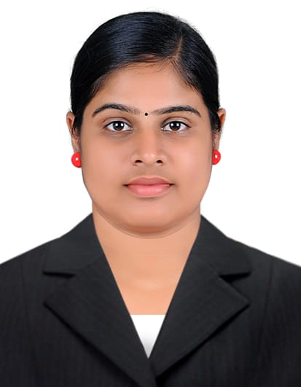

E-mail : reshmaambady9745@gmail.com

Dubai – UAE

Good experience in ticketing
SEEKING JOB AS A DATA ENTRY OPERATOR CUM JUNIOR ACCOUNTANT
RESHMA A. RAJAPPAN

Objective
Looking for a career in a challenging work environment, where I can prove my ability through hard work, with a high degree of integrity, loyalty, and team spirit to enrich and grow professionally while contributing my best.
Work Experience
Napoli Foodstuff LLC (Food Manufacturing Company),Al Saja,Sharjah UAE (Jun’19 till date)
Working as a junior accountant from (August ’19 to till date) in Napoli Foodstuff LLC,Al Saja Sharjah.

Work profile:
Working as Junior Accountant (Jun’19 till date)
  - Making Monthly Reports.
  - Preparing raw material purchase orders
Work profile:
Worked as a data entry operator (Jun’19-July’19)
- Responsible for Data Entry
  - Dealing with daily sales entry using Tally Erp9

Aaram Tours and Travels, Thrissur, Kerala,India (June’15-May’16)
I worked as a ticketing staff cum tour operator in Aaram Tours and Travels.
Work profile:
- Responsible for working as a ticketing staff by booking domestic and international travel tickets for the customers
- Worked as a tour operator by taking care of clients’ requirements such as itinerary creation, hotel booking, travel arrangements etc.
- Also have good experience in passport services, visa handling, embassy attestation etc.

Intimate Matrimony,Thriprayar,Kerala,India (Jan’14-May’14)
Worked as a Customer care executive in Intimate Matrimony, this is one of the famous matrimonial agencies in Kerala, India.
Work profile:
Customer care executive
- Liaising with potential customers for enrollment.
        - Informing about the available offers
        - Rules and regulations
        - Payment procedures
- Follow up with the registered members
- Achieving monthly targets.

Avaran Motors (Suzuki two-wheeler dealer),Irinjalakuda,Kerala,India (Feb’13 to Dec’13)
Worked as a sales girl and customer care executive in Avaran motors, which is a leading Suzuki Two-wheeler dealer in Kerala, India.

Work profile:
Worked as Sales Girl (Jun’13 to Dec’13)
- Responsible for sale of two-wheelers
  - Dealing with customers
  - Describing Vehicle features, warranty etc.
  - Giving offer details
  - Assisting the customers in registration, payment and insurance
Worked as a Customer care executive (Feb’13 to May’13)
- Liaising with potential customers
- Attending Customer calls and providing enquiry details
- Booking and handling of vehicle service and follow up.

Education Qualification
- S.S.L.C in the year 2006-2007.
- Completed +2 in the year 2007-2009
- Graduation in Bachelor of Computer Application(BCA) from Bharathiar University, Coimbatore 2013-2016
- Diploma in Travel and Tourism Consultant( IATA) 2014-2015
Strength & Skills
- Hard working and dedicated towards work.
- Ability to work under pressure& prioritize multiple tasks.
- Flexible team player with a positive approach.
- Excellent communication and convincing skills.
- Quick learner & efficient to apply knowledge effectively.
Hobbies - Driving, watching movies and listening to music.

Personal Information
Permanent Address : Suriasree House, Koodapuzha, Chalakudy PO,
Thrissur, Kerala, India - 680 307. Mob: +91-9447559604
Date of Birth : 17 -10 - 1991
Nationality : Indian
Religion : Hindu
Sex : Female
Marital Status : Married
Visa status : Residence Visa.
Passport No : N 7630469
Passport Issue Date : 17 – 02 – 2016
Passport Expiry Date : 16 – 02 – 2026

Languages Known : English, Hindi & Malayalam
Reference : can be provided if required.

Declaration
I hereby declare that the above information is true to the best of my knowledge and belief.

Yours Sincerely
Date: 08/10/2020 Reshma Sreekumar

