AMEENA HANAN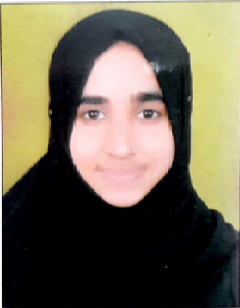

Sharjah, UAE.

Tel: +971 565215918 /0503604352

binthepakeer@gmail.com

**-------------------------------**

**Professional Objective:**

To pursue a long term career in an organization that provides opportunities for career growth and professional development in a challenging way and provides competitive environment where excellent communication & organizational skills could be strengthened.

Profile

* Highly talented innovative professional with progressive experience in Teaching and Leading the team.
* To serve the organization with utmost dedication and integrity and to achieve organizational and personal goals efficiently and effectively.
* Ability to communicate effectively with a diversity of people.
* Proactive, sincere, flexible, multi tasking and hard working.
* Team building and leadership with a diplomatic and motivational style.
* Extensive technical experience in the Subjects Under content based Instructional Methodology of Teaching**.**
* Proficient in the use of various computer programs and applications including MS Office.

Educational Qualifications:

**BACHELOR OF UNANI MEDICINES (Incomplete)**

Unani College of Medical Science.

Bangalore, Karnataka, India.

**ISLAMIC STUDIES:-**

**JAMIA MOHAMMADIYA MANSURA KULLIYA AYSHA SIDDIQA (1 Year)**

Bangalore, INDIA

**JAME UL ULOOM JAMIYA MASJID (2 Years)**

Bangalore, INDIA

Professional Experience

**Talent Research Foundation, Mangalore**

Position: Teacher/Coordinator

Trainings undergone

* **St. Agnes Girls High School** Training and Workshop in Mangalore India.

Course Includes **Discussion and How to prepare Lesson Plans.**

* **Girls Islamic Organization of India**

Actively Participated in Camps and awarded certifications for best presentation

* **Lady Hill Composite High School** in Mangalore Karnataka.

Course Includes Basics Studies and **Creative Teaching Aids**.

* + 1. Skills
* Ability to start from zero level.
* Capable to meet challenges, Creative thinker.
* Ability to work independently and as a team.
* Ready to work under pressure, Good Communicator.
* Quick Learner, Challenger, Hard worker, good writing skill.

Personal Information

**Date of birth:** 25/05/1995

**Visa:** Husband Visa

**Marital status:** Married.

**Nationality:** Indian.

**Passport No:** P2784625

**Language Proficiency:** English, Hindi, Kannada, Malayalam, Urdu, Arabic.

I declare that the information given above is true to the best of my knowledge.

Sharjah. Ameena Hanan