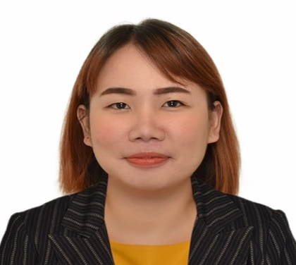**Mary Glo C. Trogue, DOH MLT PASSER**

Al Falah Street Abu Dhabi, United Arab Emirates

Email Address: maryglotrogue@gmail.com

Contact Number: 0502659362

**PROFILE**

* **DOH Passer, Medical Lab Technologist July 2019** (Ready for Licensing)
* **ASCPi Passer August 2018**
* **Registered Medical Technologist, Philippine Medical Technology Board March 2016**
* **BLS Certified- BLS Valid Until 2020**
* Oral and written communication skills.
* Skill to identify and resolve problem in a timely manner.
* Clinical Microscopy, Parasitology, Hematology, Clinical Chemistry, Blood Banking and Serology, Drug Testing and Bacteriology theoretical and working experience.
* Acted as phlebotomist in OPD and in-patients during warding.

**EDUCATIONAL ATTAINMENT**

Bachelor of Science in Medical Technology- Wesleyan University- Philippines

**PROFESSIONAL EXPERIENCE**

* VLF Medical Clinic

6-C Marcelo Bldg. Caruncho Ave., San Nicolas, Pasig City, Philippines

April 18, 2016 – August 2, 2019

* Medical Technology Intern

Nueva Ecija Doctor’s Hospital, Inc.

June 2014– October 2014

**TRAININGS AND SEMINARS**

* **Render i-Magic E7 Fully**

**Auto Chemistry Analyzer**

St. Ignatius de Loyola Health Care Services- Pasig City, Philippines May 16,2016

* **Building Up Medical Technologists Capabilities through Local Empowerment**

Wesleyan University- Philippines Auditorium, Cabanatuan City, Nueva Ecija, Philippines November 18, 2016

* **Seminar Workshop on the Manual Operations for Drug Testing Laboratories**

Margarita Hall, Hotel Supreme, Magsaysay Ave., Baguio City, Philippines

April 26- 28, 2017

* **2nd Continuous Professional Development Lecture**

Our Lady of Fatima University Amphitheatre, Cabanatuan City, Nueva Ecija, Philippines August 23, 2017

* **53rd PAMET Annual Convention**

**Raising the Gold Standard for World- class Medical Technologists**

Marriott Grand Ballroom, Pasay City, Philippines November 23, 2017

* **Basic Life Support Course**

**Philippine Heart Association Council on Cardiopulmonary Resuscitation**

Premiere General Hospital, Baler, Aurora, Philippines March 1, 2018

* **Seminar on Quality Control and Data Management in Medical Laboratories & Laboratory Equation: The Cost of Producing 1 Test Result**

Top Star Hotel, Cabanatuan City, Nueva Ecija, Philippines June 8, 2018

**CHARACTER REFERENCES**

* **Vikki Lou O. Flores**

VLF Medical Clinic

Chief Medical Technologist

Mobile Number: +639156476688

* **Marilou T. Olimpo**

VLF Medical Clinic

Laboratory Owner

Mobile Number: +639357162335

Telephone number: (02) 634-6338

