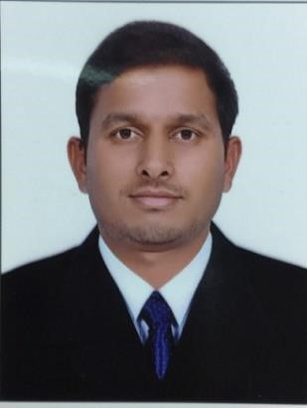CURRICULUM VITAE

**AMEER M KARADGI**

**Butina Street Rolla Park Sharjah UAE·**

**PH: 0526825454**

**Email · aamirsheikhmuskan@gmail.com**

# CAREER OBJETIVE

To pursue a challenging career and be a part of progressive organization that gives a scope to enhance my knowledge and utilizing my skills towards the growth of the organization.

# EDUCATION

* High School

* Completed 6-month diploma in MS Office and TALLY in 2013 from Vasco-Da-Gama Goa, India

# WORK EXPERIENCE

**Customer Service Executive/ Front Office Receptionist**/Business Development Executive at

Reem Medical Diagnostic Centre LLC (An Avivo Group Enterprise) From DEC 2014 till Date (8 Years 3 Months)

# DETAILED JOB DESCRIPTION

* Registered patients, assisted them in completing medical forms and guided them regarding medical policies to be followed, timing and services available.
* Scheduled appointments.
* Documented and organized patients' records for reference.
* Maintained front office supplies and record of daily monetary transactions.
* Checking patients in at the time of their appointment and collect

their co-payments.

* Checking patients out and scheduling their follow-up appointment.
* Answering a multi-line phone system, taking messages, scheduling patient appointments and answering their queries.
* In charge of filing, faxing, scanning and e-mailing any and all paperwork involved with each patient.
* Verifying each patients' insurance and eligibility benefits.
* Accommodated all client needs in-person as well as via e-mail, fax and/or telephone.
* Maintained a safe, clean, professional and secure working

Environment.

* Provided general administrative and clerical support.
* Greeted persons entering office and escorted guests.
* Performed responsibilities of handling, maintaining and recording cash transactions and kept records of daily credit card transactions.
* Ensured that the reception area is always clean and organized to comply with safety regulations.

# PERSONAL DETAILS

Name : Ameer M Karadgi

Date of birth: 05-09-1988

Nationality : Indian

Marital status: Married

Visa status : Work Visa

Passport No : L9483678

UAE License : 860539

Languages spoken English, Hindi, Konkani, Marathi, Kannada, Urdu

**DECLARATION**

I hereby declare that the above furnished details given by me are true to the best of my knowledge and belief.

Sharjah Ameer M Karadgi