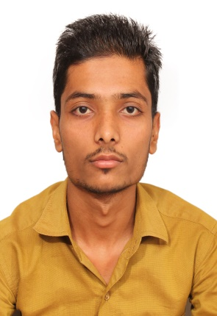**Abdul Kalam khan**

**Data Entry Operator with 1.9 Years Indian Experience**

D.O.B.: 26-May-1995

Nationality: India

Location: Mumbai, India

Mobile: +91 7977167142

Email: kalamkhan8655@gmail.com

Indian Passport no: S4591477

­­­

# SUMMARY

Highly accurate Pharmacy Data Entry Operator with **1.9** **years of experience**. Areas of expertise include Transcribe Dr. prescription received through electronic forms and code them accurately in electronic database systems. **Good typing** speed and accuracy, strong organizational and team skills.

**PROFESSIONAL EXPERIENCE**

**Data Entry Operator**

**HEXAWARE TECHNOLOGIES (BPS) PVT LTD. January 2018 – Present**

**Hexaware Technologies Limited (HTL).** Is an information technology and business process outsourcing service provider company based in Navy Mumbai, India. With an annual revenue of US$ 677.7 million (2018).

**Responsibilities and Role details:**

**Working as Health Information technicians to maintain Electronic Medical Records:**

* Manage medical records; review each patient's physical chart, including the medical history, doctor's notes and current medications.
* Transcribe Dr. Prescriptions received through electronic forms and code them accurately in electronic database.
* Ensure that patient receives correct, exact and timely drug s as prescribed by the Dr.
* Ensure proper paperwork is in place for ‘*controlled*’drugs whose circulations are controlled by law.
* Ensure that each patient’s records are perfectly managed and updated from time to time.

# SPECIALIZED SKILLS

* Ability to type at least **35 WPM** with good accuracy.
* Proficiency with popular computer software such as Microsoft Word and Excel.
* Understanding of spreadsheets, data processing, and file management.
* Outlook: Very much familiar to use Outlook.
* Able to maintain data confidentiality and privacy.
* Excellent interpersonal and communication skills.
* Multi-tasking abilities with proficiency in organizing and managing different tasks.

# EDUCATION

**Dnyan Ganga Education Trust**, Mumbai, Maharashtra, India

BCOM 2016

# LANGUAGES

**English -** Excellent reading, writing and speaking

**Urdu -** Excellent reading, writing and speaking

**Hindi -** Excellent reading writing and speaking

# OTHER INTERESTS

Playing cricket, watching YouTube videos,

**THANKING YOU.**

**Abdul Kalam Khan**