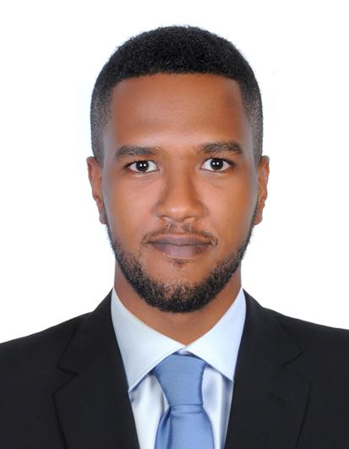 | Ammar Yousif  0521222093 | E: ammaryousif000@gmail.com  Sharjah, UAE

Professional summary | - I am seeking a competitive and challenging environment where I can serve your organization and establish an enjoyable career for myself.  - I want a highly rewarding career where I can use my skills and knowledge to help the company and my coworkers be successful.  - I am seeking employment with a company where I can use my talents and skills to grow and expand the company.

Work history | Contact Point Verification Agent , Cpv  Dubai Islamic Bank | Dubai, UAE 12/2016 to Current  - Processing of retail applications (Credit Card, Personal Finance, Auto Finance- individual and Auto Finance- companies, Home Finance – SBF).  - Ensure all applications are proper verification and to verify the authenticity of the addresses / Office / Residence / Business of the finance application, by carrying out physical inspection and through telephone call.  - Investigate and analyze the causes, methods and processes of fraud activities and generate fraud prevention and analysis reports  - Maintaining daily MIS of the number of applications completed  - Making sure that each verification is done according to the bank policy and procedure.  - Giving training for the new joiners  - Field visit Support Team ( additional task)  - Regular communication with the entire Branches Staff, Managers, SSMs, with regards to customers' records of employment, business relationship, etc.  - Recommend ways to continuously improve the process & increase efficiency while reducing the turn-around-time  working as a clerk in the EJARI SECTION (LEASE MANAGEMENT SOLUTIONS  Emirates post corporation 2011-2015  - Having the duty of updating the customers about the status of their tenancy contracts  - Performing a variety of administrative or executive support tasks that are highly confidential and sensitive like  - renewal, cancellation registration and printing of agreements  - Reporting directly to the Operation Manager  - Coordinate with other employees and manage to solve admin issues and other concerns  - Prepare required registration forms and process payment of related fees  customer service  TNS Middle East and Africa 2010-2011  - Dealt directly with the customers to handle their complaints and other verifications  - Make reports related to customer issues and submit to my seniors  - Follow up and update the customers to solve their matters and inform them in case was necessary

Skills  Training cources | - Data management - Self-motivated - Observant - Windows XP knowledge  - Anti-money laundering & counter financing of terrorism.  - Foundations & Principles of Islamic Finance.  - KYC/AML.  - Performance Management.

Education | Secondary School Edcation June/2010  Al Khalij al Arabi high school

