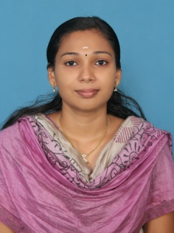

**ANUSHA . MK**

Mobile: +971504284797

Email Id: mkanusha64@gmail.com

**VISA STATUS: - On Husband Visa**

* **VISA EXPIRY : - 01/03/2021**

**Career Objective**

To build a successful career by working in a promising, creative and challenging environment where I can apply my knowledge and experience to the best of my ability, thus contributing towards organizational goals and the progress of the institution, along with personal development.

**Educational Qualifications**

|  |  |  |  |  |
| --- | --- | --- | --- | --- |
| **COURSE** | **M.com** | **B.com with**  **Co-operation** | **VHSE** | **SSLC** |
| **UNIVERSITY BOARD** | Calicut university | Calicut university | VHSE Board | SSLC Board |
| **MARKS** | 57% | 63% | 79% | 63% |

**Professional Experience**

* 2 year experience as an accountant with an Accounting & Tax consultancy
* 1 year experience as a junior accountant in Trelog L L C (SHIPPING & LOGISTICS ) IN DUBAI.

**Computer Exposure**

* MS Office
* DCFA
* Tally
* Foreign Accounting - Quick books & Peachtree

Strength

* Quick Learner
* Well organized & work very well in a team
* Time management skill
* Dedicated, sincere & hard working

**Personal Profile**

* Nationality : Indian
* Age & D.O.B : 26 yrs , 29th may 1991
* Gender : Female
* Marital status : Married
* Languages known : English, Hindi ,malayalam

**Contact Details**

**Permanent Address**

Pulincholi Thazhe Kuniyil (H),

Chombala P.O.

Kozhikode District,

Vatakara,

Kerala, India.

PIN: 673308

Ph: ++971504284797

**Declaration**

I hereby declare that the above mentioned details are true and correct to the best of my knowledge and belief.

Calicut (sd/-)  **Anusha mk**