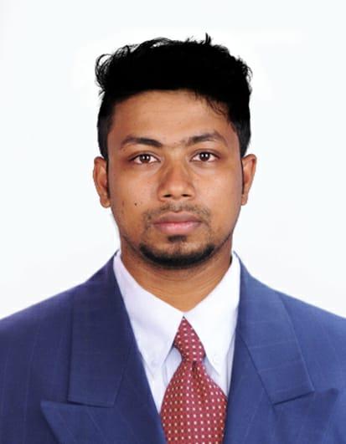

**ALSHAMAD**

E-mail: [arifalshamad@gmail.com](mailto:arifalshamad@gmail.com) Contact: : 0504226558

**OBJECTIVE:**

Seeking an **Insurance Coordinator** position in a stable company where I can use my skills to benefit the company. Managed filing and tracking **insurance claims** and informed patients of their **claims** status. Processed **insurance** and disability **claims** in a timely manner.

**SKILLS:**

Data entry Customer service

Report Verification

Documentation and reporting

Mail Handling

**ORGANIZATIONAL EXPERIENCE:**  AUGUST 2018 – AUGUST 2019

**INSURANCE COORDINATOR** | SCIO Management solution pvt | Chennai, Tamilnadu

* Worked as a Group co-coordinator for 4 months.
* Trained fresher’s about insurance verification ,chemotherapy and Radiology.
* Getting approvals for medical procedures.
* Coordinating with insurance companies for obtaining information on new policies and their coverage
* Assisting invoicing department in insurance processing and billing.
* Ensuring coverage of claims, guiding staff for correct use age of claim forms, approval papers.
* Explaining coverage of medical benefits to patients when required
* To network with insurance companies to obtain accreditation as a provide
* To liaise with insurance companies regarding eligibility, payments, approvals, reconciliation and other requirements.
* To liaise with patients regarding their eligibility and entitlements.
* To maintain and update records related to pre-approvals and reconciliation.
* To coordinate and co-operate with colleagues of the same department and other related departments for smooth running of Insurance operations.

**EDUCATION:**

2015 – 2018 Bachelor of Business Administration from, KSR college of Arts and Science Tiruchengode, Tamilnadu.

2015 Higher Secondary from,

AKT Matriculation and Higher Secondary School.

2013 High School from,

AKT Matriculation and Higher Secondary School.

**PROFICIENCY:**

Microsoft Office, ICD 10 code(Oncology & Radiology),Insurance verification.

**CLIENT:**

Worked for US clients ,Group Name(Alliance cancer specialist)Pennsylvania.

**PERSONAL DETAILS:**

Language Known - Tamil and English.

Nationality - Indian

Visa Status - 3 Month visit visa (Ending on 15th Dec 2019)

Current Location - Dubai

Present Address - Flat 201, Abu hail,Dubai.

Permanent Address -158,THIRUVALLUVAR NAGAR,NAGALR POST,KALLAKURUCHI TALUK, VILLUPPURAM, TAMIL NADU- 606203,INDIA.

**DECLARATION:**

I hereby certify that the above information is true and correct to the best of my knowledge.

**Alshamad**