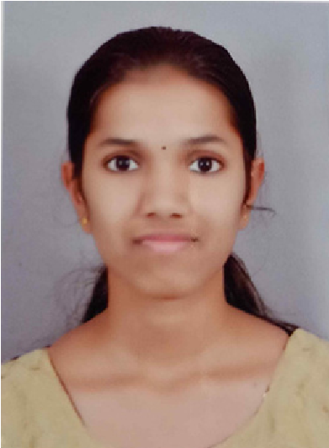

**ATHIRA UPENDRAN**

**REGISTERED NURSE** **DHA ID : 13211532**

# MOH ID : 277419

**PROFILE**

CONTACT

+971582288924

athiraupendran@gmail.com

Abu hail, Dubai

EXPERIENCE

MANIPAL HOSPITAL WHITEFEILD BANGALORE

POSITION

:

Staff Nurse (medical and surgical ward

)

DURATION : 13/06/2019 to 30/07/2022

EDUCATION

PBBSC -Nursing -Karnataka - 2021

GNM- nursing - Karnataka - 2018

Higher secondary - 2015 -board of HSE

Hi

gh school - 2013 - State board of examination

**J**

**OB SUMMARY**

Prepare and administers prescribed medications enteral and parenteral

route.

Delivers regular updates to patients and family members to help them

arrive at decisions regarding treatments

Monitors

patients

progress

and

alerts

attending

physicians

when

sudden changes occur that calls for emergency intervention

Sends orders for diagnostic tests such as ECG, CT scan, MRl and X-Ray

Setup

and

monitored

life

support

equipment

and

devices

such

as

cardiac monitors, transducer, pressure lines, oxygen delivery devices,

mechanical ventilators and pulse oximeter

Performed approved and prescribed diagnostic procedures based on

patient's clinical status

Evaluated

patient's

assessment

record

and

lab

data

results

to

determine whether an emergency intervention was necessary.

EQUIPMENT'S HANDLED

Suction Apparatus

Glucometer

Pulse Oximeter

Sphygmomanometer

Cardiac Monitor

Steam Inhaler

Machine Nebulizer

Oxygen Cylinder

Provides nursing care to patients with post-surgical procedures,

acute/chronic medical illnesses

Advocates needs of, and assists patients and significant others in

receiving proper medical care during hospitalization

Sends orders for diagnostic tests such as EKG, CT Scan, MRl and X-Ray

Coordinates with patient, family, social worker, attending physician in

planning and facilitating discharge and continuing needs for home care

or transfer to an extended care facility.

Setup and monitored life support equipment and devices stich as

cardiac monitors, transducer, pressure lines, oxygen delivery devices,

mechanical ventilators and pulse oximeter

Communication with Laboratory, physical therapist, dieticians,

physicians, family members, clients.

Assisting patients and their families throughout the process.

Administration of medications, sterile wound care, dressing changes.

responsibilities include:

To obtain a position that would be

sensitive to the needs of an

experienced Nurse where I could

contribute my skills effectively, I

would like to get an employer who is

willing to utilize my knowledge and

experience in patient care.

Compassionate and Patient-Family centered Registered Nurse

with clinical experience in Medical and Surgical Unit.Skilled

at performing quick yet accurate patient assessments and

Emergency treatments. Adeptly multitask to deliver quality

care to several patients simultaneously from admission to

discharge.

PROFESSIONAL SUMMARY

**REG.NO : 222264 (KARNATAKA STATE**

**NURSING COUNCIL)**

**LICENSE :DHA ID :13211532**

# LICENSE :MOH ID :277419

**PROCEDURES HANDLED**

IV Cannulation

Bladder Irrigation

CPR

Suture removal

Nebulization

Foley's Catheterization

STEAM IN HALATION

ECG Tracing

Blood transfusion

Colostomy care

Dressing

Tracheotomy care and Suctioning

# PERSONAL DETAILS

FULL NAME : ATHIRA UPENDRAN

DATE OF BIRTH : 11/12/1998

GENDER : FEMALE

NATIONALITY : INDIAN

TRAINING PROGRAMME

Participated in BLS

Participated in Clinical Teaching

both planned and incidental

Participated in continues Nursing

Education

Marital Status : SINGLE

FATHER'S NAME : UPENDRAN KK

MOTHER'S NAME : SATHY UPENDRA

CAN SPEAK : MALAYALAM,ENGLISH,HINDI,KANNADA

RELIGION : HINDU

PASPORT NO : V7442815

PASPORT EXPIRING DATE : 27/02/2032

# DECLARATION

I hereby declare the above-mentioned information is true and verifiable to the best of my knowledge and I bear responsibility for the correctness of the above mentioned particulars.