AZNA FAHA

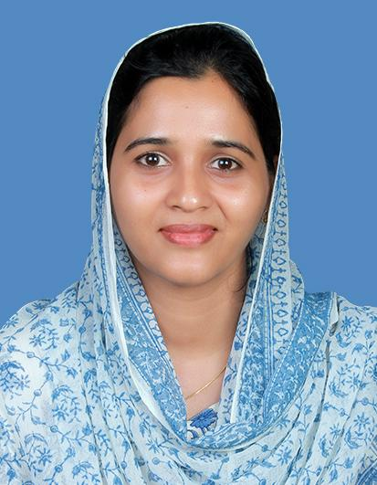
New Muweilah Building, Muweilah, Sharjah, UAE
Al Muraad House, Thaikkatukara P.O, Aluva, Ernakulam, Kerala, India
Phone (UAE): +971 523767723 / +971 556939723
Phone (India): +91 9496255928 / +91 9446182584
Email: aznafahad@gmail.com

Career Objective
Dedicated and compassionate Registered Nurse with a strong commitment to providing quality healthcare. Skilled in critical care, emergency response, and patient advocacy, with a strong emphasis on teamwork, punctuality, and empathetic care.

Professional Qualifications
- - B.Sc Nursing (2008–2012), Government T.D. Medical College, Alappuzha, Kerala
- - Registered Nurse – Kerala Nurses & Midwives Council
- Registration No: 59687 (April 2013 – valid until April 2028)
- - Licenses:
- DHA License No: 33555297
- MOH UAE: Eligible Licence Holder

Certifications
- - Basic Life Support (BLS) – American Heart Association
- - Emergency Life Support (ELS)
- - Basic Certificate Course in Palliative Nursing (BCCPN)

Education
- - 12th Standard, 2007 – Govt Girls HSS, Kayamkulam
- - 10th Standard, 2005 – Govt HSS, Valiazheekal

Work Experience
CHC Chengamanad (Nov 2023 – Mar 2025)
Palliative Care In-Charge Nurse, OPD Nurse & School Health Nurse
- - Managed palliative care and outpatient services
- - Handled emergency cases and casualty services
- - Administered routine and mass immunizations
- - Coordinated school health programs

Govt District Hospital, Aluva (Sep 2019 – Nov 2023)
Nursing Officer – Operation Theatre
- - Assisted various surgical procedures and managed pre/post-operative care

KIMS Hospital, Thiruvananthapuram (Jan 2019 – Sep 2019)
Staff Nurse – Surgery ICU

Govt T.D. Medical College, Alappuzha
- - Staff Nurse – Surgery ICU (Apr 2013 – Sep 2015)
- - Staff Nurse – CTVS ICU (Nov 2016 – Jun 2017)

Clinical Skills
- - Post-operative and critical care
- - Emergency and casualty management
- - Immunization and documentation
- - Ventilator management and sterile techniques
- - Biomedical equipment handling
- - Patient education and counseling
- - Drug administration and CPR

Surgical Procedures Assisted
- - Gynecology/Obstetrics: C-section, hysterectomy, sterilization
- - General Surgery: Hernia, biopsy, appendectomy
- - Orthopedics: TKR, ORIF, arthroscopy
- - ENT: FESS, tonsillectomy, thyroidectomy
- - Ophthalmology: Cataract surgery

Equipment Proficiency
ECG, Pulse oximeter, Infusion/syringe pumps, Cardiac monitor, Laryngoscope, Suction apparatus, Thermo blanket, SCD, Nimbus bed

Clinical Procedures
IV/IM medication, Oxygen therapy, ABG sampling, Ryle's tube insertion, Catheterization, TPN, Transfusion therapy, Intubation support, CPR

Strengths
- - Hardworking and sincere
- - Excellent communication and interpersonal skills
- - Team-oriented and punctual

Personal Details
- - Date of Birth: 23 May 1990
- - Sex: Female
- - Marital Status: Married
- - Nationality: Indian
- - Languages: English, Malayalam
- - Passport No: S8968784 (Valid until 30 Oct 2028)

