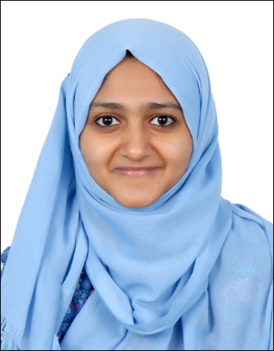

Mobile: +97156-6136805

Email: ka.bisinisameer@gmail.com

**BISINI SAMEER**

**CERTIFIED PROFESSIONAL CODER 01991007**

# SUMMARY

Professional Licenses

Certified Professional Coder(AAPC) Membership ID: 01991007

Completed training sessions for Certified Professional Biller (CPB)

# CAREER OBJECTIVE

Pursue the challenging career as a reputed medical coder and continuously work hard for higher achievement in my career through constant learning.

Seeking to leverage coding guidelines knowledge and strong analytical skills to implement smooth coding service at work place. Widen the horizon of my knowledge and sharpen my skills and utilize the same to the advantage of the organization and its surroundings.

# SKILLS

I am seeking role in a dynamic organization to contribute accrued expertise in charting a mutual grow path.

# TECHNICAL SKILLS

Confident to work with Microsoft Word, Excel, and power point.

# PROFESSIONAL SKILLS

* Extensive knowledge of medical terminology, Anatomy & Physiology
* Knowledge in HAAD and DHA guidelines
* Knowledge in Surgery and Anesthesia coding
* Knowledge in Pre-approval
* Excellent data entry skills
* Strong understanding of E/M, ED, ICD-10-CM, CPT & HCPCS
* Expertise in medical record review to abstract information required to support accurate outpatient coding & inpatient coding
* Assure the assignment of complete, accurate, timely and consistent Codes for each chart assigned.

# EDUCATIONAL QUALIFICATIONS

Certified Professional Coder (AAPC)

Master of Business Administration (MBA) in HR

From MG University, Kerala

# ACADEMIC ACHIEVEMENTS

Second rank holder in MBA university examinations (2010-2012)

College topper during both the years of MBA course.

College topper during the final year of BBA course.

# WORK EXPERIENCE

* Trained to assign ICD and CPT codes to patient medical records.
* Qualified to work with patient charts, medical documentation and medical insurance records.
* Experience in assisting HR managers at various organizations. Skilled in administering, scheduling appointments, maintaining records and information, ensuring smooth communication and act as liaison between HR managers and employees.

# SPECIALIZED AREAS

Knowledge of medical terminology, Anatomy, Physiology & disease conditions.

Assure the assignment of complete, accurate, timely and consistent codes by the medical coding unit Classification of Diseases (ICD)-10, clinical Modification; Current procedural Terminology(CPT) Review and abstract relevant clinical data/medical records to select and sequence the appropriate ICD-10 diagnosis.

# ADDITIONAL SKILLS

* + ICD, CPT and HCPCS
  + Medical terminology
  + Able to maintain good rapport with patients and colleagues
  + Data entry and management
  + Analytical skills
  + Time management

# PERSONAL DETAILS

Husband Name : Sameer P. A.

Date of Birth : 03-05-1989

Visa Status : Residence Visa

Gender : Female

Linguistics : English, Hindi, Malayalam,Tamil

I do hereby declare that the information furnished above is true to the best of my knowledge and belief.

BISINI SAMEER