**CURRICULAM VITE**

**JOSE K. JOSEPH** 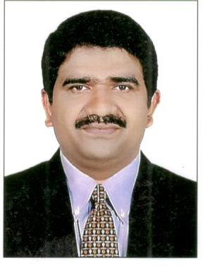

**POWER HOUSE Bldg.**

**Flat No.301, BUTHEENA**

**SHARJAH ,U A E.**

**Phone : 0528344964**

**Email Id : josejoseph74@gmail.com**

**POST APPLIED FOR : RADIOGRAPHER**

**U A E Ministry of Health Registration No . 138600**

**Saudi Commission for Health Specialties Registration No . 10-A-T-0346125**

**TECHNICAL QUALIFICATION :**

**Two Year Diploma in Radiography.**

**EDUCATIONAL QUALIFICATION:**

**Pre-Degree from M G University, Kerala.**

**WORK EXPERINCE:**

**Presently working as a Radiographer in Sunny Al Nahda Medical Centre, Near Al Nahda park, Sharjah, U A E, From 21/06/2016 to 18/06/2018**

**As a Radiographer in Central Security Hospital, Under Ministry of Interior, Abha, K S A, from**

**30/01/2010 to 22/12/2015.**

**As a Senior Radiographer in Umkal Health Care Pvt.Ltd. Palam Vihar, Gurgaon, Haryana from**

**15/03/2008 to 24/10/2009.**

**As a Radiographer in Ark Hospital D L F Phase -1, Gurgaon, Haryana from 01/01/2000 to 21/11/2007.**

**As a Radiographer in Indian Red Cross Society,Bel Air Hospital Panchagani, Maharashtra from 01/07/1995 to 08/10/1997.**

**As a Radiographer in Lisie Hospital Cochin, Kerala from 01/06/1994 to 22/06/1995.**

**PERSONAL DETAILS :**

**Date of Birth : 20th May 1974**

**Father’s Name : K.C Joseph**

**Sex : Male**

**Marital Status : Married**

**Nationality : Indian**

**Permanent Address : Kochupulickal House**

**Onamthuruthu P.O**

**Kottayam Dt.**

**Kerala,India -686602.**

**Language Known : English,Hindi,Malayalam & Arabic.**

**PASSPORT DETAILES:**

**Date of Issue : 09/06/2012**

**Date of Expiry : 08/06/2022**

**Passport No : K 4677872**

**Place of Issue : JEDDAH(K S A)**

**Date :**

**Place : Jose K. Joseph**