Curriculum Vitae

Application for | GUEST RELATION EXECUTIVE
Experience | 1 YEAR 3 months
Availability | Immediately

Personal Information
Title | Mrs | 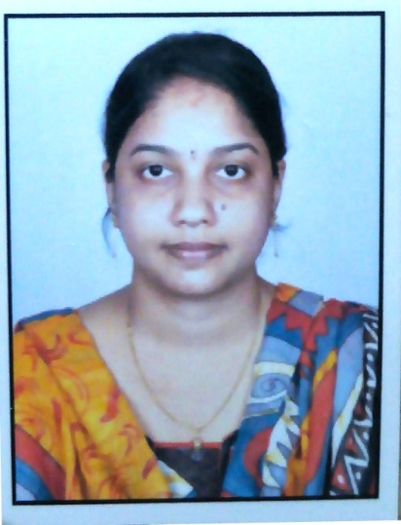
Surname | PASAGADUGULA
Name | HARIKA
Known Name | HARIKA
Nationality | INDIAN
Country of Birth | INDIA
Date of Birth | 15/06/1990
Age | 30
Gender | FEMALE
Marital Status | MARRIED
Contact Telephone | MOBILE : +971503032024 ,+971562415665
Email | haru.p260@gmail.com
Skype | harika.pasagadugula
Current Work Address | Not working
Employment history | Al Ahalia hospital mussafa worked as a Guest Relation Executive(GRE ) operator from 2017 to 2018
Language | English, Telugu, Hindi

Qualifications

Qualification Name | Institution Name  University / College Name | Date of completion | Type  (Degree / Diploma)
M SC ( MEDICAL PHYSIOLOGY) | SRI VRNKATESWARA INSTITUTE OF MEDICAL SCIENCES | 2013 | Post graduate
BSc MICROBIOLOGY | SAMYUKTHA DEGREE COLLEGE | 2010 | Degree

- Skills and Abilities:

I am highly energetic young professional, not afraid to take up new tasks, always eager to accept new challenge.
Key Skills: Analytical ability,decision making, leadership, planning,presentation,problem solving, always willingness to learn new and difficult task.

- Computer Programs:

Details
MS office (word, power point,excel)

Work experience:

Al ahalia hoapital musaffah abudhabi:

- Worked as a GRE from 2017 to 2018
- Registration of patients, Answering phone calls and directing calls to appropriate departments (operating system),Scheduling appointments to patients, checking insurance eligibility.
Qualification summary

- Six months Training in ICD 9 & 10, CPT coding in T. Nagar, Chennai.
- Successfully completed Advance Certification in Medical Coding (for CPC exam preparation) in Altalouk medical coding centre UAE.
- Knowledgeable with regard to Medical Coding guidelines and coding techniques (ICD-9 and 10, CPT ).
- Worked as a physiology lecturer in GSL medical college, Rajamundry, India.
- Knowledge of Anatomy & Physiology, Advanced Medical Terminology.
- Very efficient in Microsoft Office Software including Word, Excel, and Powerpoint.
- Effective communication and interpersonal skills.

Visa Details:
Given name : HARIKA
Surname : PASAGADUGULA
Visa Status : HUSBAND VISA
Date of Issue : DEC 2022
Date of Expiry : DEC 2024

Declaration
I Harika, here by declare that all statements made above are true, complete and correct to the best of my knowledge.

DATE:

PLACE: ` (HARIKA)

