**CURRICULUM VITAE**

**RAMEENA NIYAS** 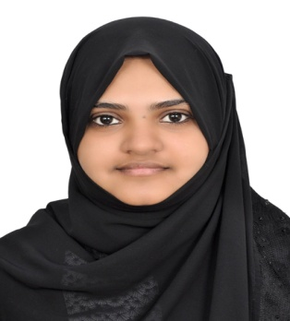

**MOB: 0509617233**

**E-mail:rameenaniyas2014@gmail.com**

**CAREER OBJECTIVE**

**To work in a challenging environment where my knowledge and**

**Qualification can be shared and enriched.**

**ACADEMIC PROFILE**

|  |  |  |  |  |
| --- | --- | --- | --- | --- |
| Course | Year of passing | Institution | Board/University | Marks (%) |
| B.Sc Microbiology | 2016 | Majlis arts and science college, puramannur | Calicut university | 70 |
| Higher secondary  Course (Science) | 2013 | MESHSS Irimbliyam , Malappuram | Board of higher secondary examination, Kerala | 80 |
| SSLC | 2011 | MESHSS Irimbliyam,Malappuram | Kerala state examination board | 77 |

**PROJECT UNDERTAKEN**

**1. ISOLATION AND CHARACTERIZATION OF SIDEROPHORE PRODUCING BACTERIA.**

As a part of my B.Sc. microbiology Course: Duration: 3 weeks, February 2016

**TECHNIQUES HANDLED**

* Antibiotic sensitivity test
* Differential staining
* Biochemical test
* Enumeration of microorganism
* Phenol co-efficient test
* Quality checking of water/ milk/food items

**INSTRUMENTS HANDLED**

* Spectrophotometer
* Centrifuge
* Laminar airflow chamber
* Autoclave
* Hot air oven
* BOD incubator
* Phase contrast microscopy

**TEACHING SKILL**

Experience in oral presentation in graduate class rooms in following subjects:

* Industrial Microbiology
* Molecular Biology
* Medical Microbiology
* Microbial genetics
* Environmental microbiology
* Biochemistry
* Environmental chemistry

**Experience**

**Two Years of experience as Microbiologist in Nizar Hospital Valanchery, Malapuram, Kerala, India.**

**PERSONAL DETAILS**

Name **:** RAMEENA NIYAS C

DOB **:** 3O -07-1996

Visa **:** Visit Visa

Sex **:** Female

Marital Status **:** Married

Religion & Caste **:** Islam, Mapila

Nationality **:** Indian

Languages known **:**  English, Hindi, & Arabic (Read & write)

Permanent address **:**  Ajman, UAE

**REFERENCE**

Mr. Sureshbabu. Vk

HOD & Course Co-Ordinator

Department of Microbiology

Majlis arts &Science college

Puramannur, valanchery.

Mob: 00919605162221

**DECLARATION**

I hereby declare that all the above details are true and correct to the best of my knowledge and belief.

RAMEENA

0509617233