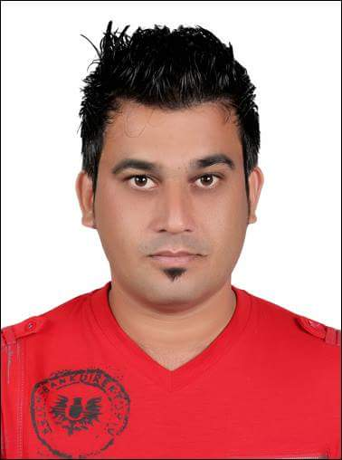AQEEL AHMAD

Father Name Mohamed Bashir

Marital Status Single

Nationality Pakistan

Year of Birth 1982

Passport Number NV1157302

Position Driver Cum Messenger

Mobile No. + 971501446709

Email address malikaqeel85@yahoo.com

EDUCATION AND PROFESSIONAL STATUS

F.A. from Post Graduate College Haripur Pakistan in 2005.

Previous Experience: Company; Auto Rent LLC

Worked Time Period: 2010 – 2016

EXPERIENCE RECORD

Responsibilities included:

Stand in front of the establishment/company, get keys from the drivers/customers, help with any luggage/goods, and then drive the car to a **parking** lot safely and promptly, or **parking** space near the establishment. When the car owner returns, run to retrieve the car and assist them inside.

Present working with Al-Nabooda Automobiles LLC

EXPERIENCE RECORD

Responsibilities included:

* Customer Handling
* Car Receiving from Customer
* Deliver Car to Customer
* Customer Pick/Drop
* Parts Transferring from Branch to Branch
* Parts Transferring from Warehouse to Store room
* Parts Receiving from Port
* PDI Cars Receiving from Port
* PDI Cars deliver to Service Centre as per their Request(Logistics)
* Car Registration/ Renewal of Registration/Passing Of Vehicle

I am well aware with Automobile Industry. Exclusively know about all the pre requisites for Logistics.

I have total 9 year experience of driver but more than 4 Year I have spend in Logistics field and currently working in most competitive group Al-Nabooda Automobiles. As a responsible candidate I am ensuring timely delivery of tools, parts, cars and other automobile item to predetermined sides and customer on specific routes, reviewing orders prior to delivery. Although I am well familiar with complete UAE routes.

LANGUAGE CAPABILITY

English : Fluent

Arabic : Good

Urdu : Fluent

**Reference: To be furnished on demand.**