**Abdulrahim Qaraqish**

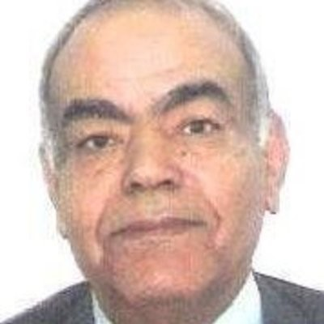

ABUDHABI UNITED ARAB EMIRATES

aqaraqish@yahoo.com

Mobile No.: +971 562786562

MD , FESC

**PROFILE:** Provided adept inpatient care for Coronary Care Unit & Outpatient Clinic patients including performing accurate cardiac diagnostic procedures as well as teaching rounds and giving tutorials, and lectures.

**EMPLOYMENT HISTORY:**

* **Consultant Cardiologist, Medical Park Consultants One Day Surgery, Abu Dhabi:**

*January 2018 – Present.*

* Provided strong leadership and expertise for clinical cardiology, inpatient and OPD clinics. Interpretation of patient data.
* **Consultant Cardiologist, Amrita Medical Center, Abu Dhabi:**

*September 2015 –December 2017*

* Proficiently handled all outpatient clinical complete diagnostic procedures, maximizing quality patient care.
* **Consultant Cardiologist, Almazroui Medical Center One Day Surgery, Abu Dhabi:**

*August 2013 – September 2015*

* Delivered strong guidance and proficiency for clinical cardiology, inpatient and OPD clinics. Interpretation of patient data.
* **Consultant Cardiologist, Alissra Hospital, Amman Jordan:**

*May 2011 – April 2013*

* Inpatient Care, Coronary Care Units, Outpatient Clinics, Cardiac Diagnostic Procedures, Teaching rounds, tutorials, and lectures.
* **Chairman of Medicine and Cardiology Department,** Batnan **Medical Center,**  **Tobruk, Batnan-Libya:**

*September 2001 – May 2011*

* Supervision and Regulation of the Medical Staff, Doctors and technicians.
* Heading the wards, ICU and CCU.
* Reporting to the General Director and attending the weekly Hospital meetings.
* Heading the Scientific and Infection Control Committees.
* Consultant Cardiologist job commitments.
* **Assistant Professor in Cardiology and Medicine, Omar Almukhtar University, Tobruk, Batnan – Libya:**

*January 2005 – December 2010*

* Undergraduate and Postgraduate medical students Teaching. Lectures, tutorials, bedside clinical teaching, and examinations
* **Consultant Cardiologist, Head of Cardiology, Security Forces Hospital, Riyadh, Riyadh - Saudi Arabia:**

*September 1989 – September 1995*

* Regulation of the Cardiology Department, Inpatient ward and coronary care units, outpatient clinics.
* **Consultant Cardiologist, Director of Non-invasive Cardiology Lab,** **King Khalid University Hospital, Riyadh, Riyadh - Saudi Arabia:**

*November 1982 – August 1989*

* Heading unit of cardiology for Coronary Care Unit, Wards and Outpatients.
* Supervising a team in Cardiology Laboratory.
* Reporting all the hospital EKGs, Echoes, Holters and Stress testing.
* Research Studies.

**LICENCES/ EXPERIENCES:**

* Member of the European Society of Cardiology (ESC).
* Member of the European Society of Hypertension (ESH).
* Member of Acute Cardiovascular Care Association.
* Member of the European Association of Cardiovascular Imaging (EACVI).
* Member of the American Society of Echocardiography (ASE).
* Member of the Emirates Society of Cardiology (ESC).
* EAPCI member (European Association of PC CVI).
* Member of Jordan Cardio Society.

**EDUCATION AND TRAINING:**

* **Ain Shams University, 1980**

*Cairo, Cairo, Egypt*

Cardiovascular Diseases, Doctorate (Ph.D.) Clinical and Thesis in Cardiovascular Diseases

* **Ain Shams University, 1976**

*Cairo, Cairo, Egypt*

Cardiology and Medicine, Master in Cardiology and Medicine.

Full Clinical and academic cardiology and medicine

* **Ain Shams University, 1969**

*Cairo, Cairo, Egypt*

Medicine, MB, BCh

Six years of Basic and Clinical Medicine

**REFERENCES:**

* **Name:**  Dr. Saad Agoub

**Job Title:**  General Director

**Company Name:** Batnan Medical Center Tobruk, Libya

**Tel:** 0021887628327

**Email:** saad_akoub2000@yahoo.com

* **Name:**  Prof. Mohammad Arafa

**Job Title:** Professor of Medicine. Department of Medicine, King Saud University.

**Address:** King Khalid University Hospital, Riyadh, KSA

**Tel:** 0096614671661

**Email:** marafah@ksu.edu.sa

* **Name:**  Dr. Jamal Abdelkareem Dabbas

**Job Title:**  Consultant Cardiologist, FACC, FESC

**Company Name:** Alissra Hospital

**Address:** Cardiology Clinic, Alissra Hospital, Amman Jordan

**Tel:** 00962777418060

**Email:** deadseaglory@yahoo.com