**CURRICULUM VITAE**

**Maria Criselda Garcia Landingin**

**Personal Information:**  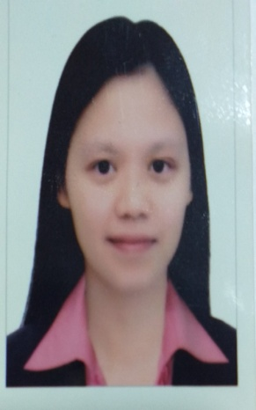

Nationality: Filipino

Gender: Female

Date of Birth: 21-July-1979

Religion: Catholic

Marital Status: Single

Languages Spoken: English, Filipino

**CurrentAddress**

Al Qusais 3, Dubai, U.A.E.

Mobile No. **+971 0503583782**

E-mail: [landinginmaria04@gmail.com](mailto:landinginmaria04@gmail.com)

**Objectives**

* To manifest my strong desire to be more productive, excellent and effective individual
* To find a stable career pathway and build as well a vital existence in the workplace
* To magnify and apply my talents and acquired skills from various industries to establish a more efficient image of an asset employee for the company

**Educational Qualification**

* **Master in Public Administration**

(Polytechnic University of the Philippines)

Completed academic units

* **Bachelor of Arts major in Political Science**

(National College of Business and Arts)

Gold Medalist for Academic Excellence

**Work Experience**

* **TEACHER ASSISTANT**

Al Ruwaidha School

Sharjah, UAE

June 2018 – Jan 2021

Role Details:

* Assists the Arabic teacher in the daily routine of the class
* Works with the Arabic teacher to enhance the learning process
* Helps the Arabic teacher to integrate different facets of learning in the course subject
* Creates a conducive and lively classroom environment for the kindergarten students to enable them to learn more and participate in the activities
* **HR ASSISTANT / ADMINISTRATIVE ASSISTANT**

Philippine Normal University

Manila, Philippines

(Office of the VP for Finance and Administration and Human Resource Department)

01 April 2005 to 31 August 2014

Role Details:

* Responsible in sourcing and selection process for various roles and requisitions
* Executes end-to-end recruitment life cycle process, screening and interviews, hiring, on boarding, employee relations and administrative functions
* In-charge of HR performance evaluation of employees
* Conducts and facilitates orientation and phase trainings for newhires and internal employees
* Assists in the various training development programs for the employees
* Maintains and updates the 201 files of all the employees
* Acts as Executive Assistant to the VP for Finance and Administration
* **RECEPTIONIST**

Crown Optical / The Eyeshop Plus

Quezon City, Philippines

01 February 2001 to 11 April 2004

* Responsible for coordinating incoming and outgoing calls and correspondence
* Attends to staff, clients and visitors’ inquiry / follow-ups in person or by telephone
* Provides administrative and clerical support
* Assists in product selling

**Other Qualifications**

* Proficient in business correspondence and writing, training and development, employee and people relations, customer service
* Has solid years of background in Recruitment and Talent Acquisition, Training and Development, Human Resources, Customer Service, Administrative functions
* Adaptive, trustworthy and results-oriented
* Highly dedicated and driven with passion and commitment
* Modest and one who values integrity and trust

**Character References**

* Miss Marjolyn Cabrera

Staff Nurse

Latifa Hospital, Dubai, UAE

+ 971 0562636041

* Miss Daisybelle F. Solo

Teacher Assistant

Al Ruwaidha School

+971 582196078