SUBI UMMER 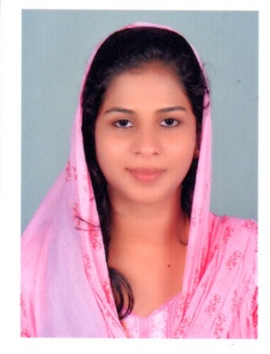

**Ph**  **:** (+971) 561646766 **| Email :** [**subyummer16@gmail.com**](mailto:subyummer16@gmail.com) **|Date of Birth** : 22 April 1996

**Gender:** Female **| Nationality:** Indian | **Passport No:** P7920327

**Visa validity:** 2022/09/29 **| Place of Residence:** Dubai **| Visa Status:** Husband Sponsorship

PERSONAL STATEMENT

An extremely well-organized and motivated receptionist with 12 months experience in a fast- paced office environment. Expert knowledge of the latest phone systems with advanced IT skills, including Microsoft Office suite. An excellent communicator known for providing customers and staff with genuinely warm and friendly greetings. A fast learner who excels when working under pressure.

**KEY SKILLS**

* Strong interpersonal and communication skills
* Answering phone, email, and face- to- face queries in a polite yet efficient manner.
* Executive and administrative support.
* Excellent time management skills which ensure I routinely meet multiple deadlines.

**EMPLOYMENT HISTORY**

**ADMINISTRATION ASSISTANT AT AGNICE CONTRACTING LLC**

**September 2019 – January 2021**

**Duties & Responsibilities**

* Greeting and welcoming guests and providing them with a positive first impression of the organization
* Directing guests and answering their questions
* Notifying other workers of visitor arrival
* Maintaining security and telecommunications systems
* Keeping office secure by following procedures, monitoring logbooks, and issuing visitor badges
* Complying with procedures, rules, and regulations on keeping a safe and clean reception area
* Documenting and communicating various actions, irregularities, and continuing needs
* Contributing to the team by accomplishing tasks as needed
* Answering the telephone; taking and relaying messages; providing information to callers
* Providing administrative and clerical support
* Preparing letters and documents
* Receiving and sorting mail and packages
* Scheduling appointments and maintaining appointment calendar
* Coordinating meetings and organizing catering and room bookings
* Scheduling travel
* Operating Point of invoice collection and releasing payment in consultation with Finance department
* Ordering office supplies
* Managing digital and hard-copy filing systems

**EDUCATION/ACADEMICS**

**Bachelor of Science (Bsc) in Biotechnology | 2013-2016**

Calicut University, St. Mary’s College, CGPA: 3.36/4

Thrissur, Kerala, India

**Higher Secondary School Certificate (HSC) | 2011-2013**

Chandra Memorial Higher Secondary School, 82%

Thrissur, Kerala, India

**Secondary School Leaving Certificate (SSLC) | 2010-2011**

Chandra Memorial Higher Secondary School, 89%

Thrissur, Kerala, India

**COMPUTER SKILLS**

* Proficient with Microsoft Office (Word, Power Point, Excel)
* Operating systems: Windows XP, 7 & 10
* Mailing Client : Outlook

**PERSONAL INFORMATION**

Place of Birth : Indian

Date of Birth : 22/04/1996

Gender : Female

Marital status : Married

Languages : English, Malayalam & Hindi

**DECLARATION**

I hereby declare that all the details furnished above are true to the best of my knowledge.

Place: Dubai, UAE yours sincerely

**(SUBI UMMER**)