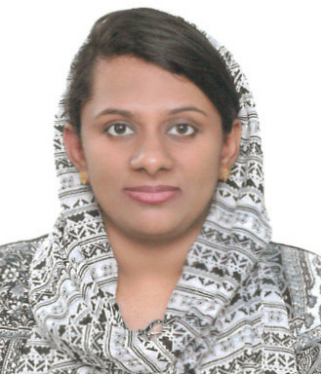

**DR.MEHA MOHAMMED**

**SHARJAH.UAE**

**dr.mehariyas@gmail.com**

**0562411911;0553783832**

**SPECIALIST ENT SURGEON WITH HAAD LICENSE.MOH ELIGIBILITY.**

**Willing to Relocate to DHA,MOH.**

**MBBS;MS ENT;**

**MRCS PART A;DOHNS PART1.**

Work Experience:

**SPECIALIST ENT SURGEON**

SHIFA AL JAZEERA MEDICAL CENTRE- BAHRAIN

NOVEMBER 2015 to MARCH 2018

**JUNIOR CONSULTANT ENT**

HOLY CROSS HOSPITAL- KOLLAM, KERALA

JUNE 2012 to AUGUST 2013

Education:

**MS OTOLARYNGOLOGY**

VINAYAKA MISSIONS UNIVERSITY- INDIA

APRIL 2009 to MARCH 2012

**MBBS**

YENEPOYA MEDICAL COLLEGE(RAJIV GANDHI UNIVERSITY OF HEALTH SCIENCES.BANGALORE.INDIA

AWARDS :GOLD MEDALIST in MS OTOLARYNGOLOGY University Examination

CERTIFICATION AND LICENSES:

DOHNS PART 1,MRCS PART A.

**HAAD (DOH) ABU DHABI.**

NHRA BAHRAIN;

MEDICAL COUNCIL OF INDIA

Any Gap in practise is due to exam preparation for MRCS.

References:1)Dr.HALEEMA MOHAMMED

Specialist Gynaecologist,DUBAI.

2) Dr. RIYAS EBRAHIM KUNJU

Specialist paediatrician.SHARJAH.UAE