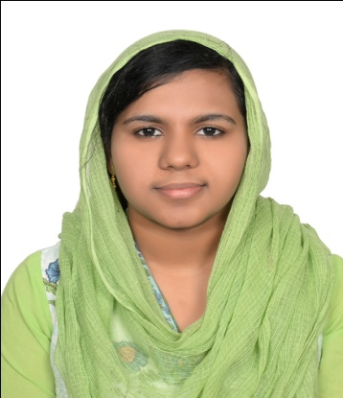  SHAMEELA SHAFEER  Contact Information:  Mobile:0509563100  Email:shemilashafz@gmail.com  Present Address:  Ajman – Al Nuaimia  Personal Data:  Date of Birth :18/09/1991  Place of Birth :Kerala  Passport No : L7737163  Date of issue :14/03/2014  Date of Expiry :13/03/2024  Visa Status :Husband Visa  Gender :Female  Nationality : Indian  Religion : Muslim  Marital Status :Married  Languages Known:  - English  - Malayalam  - Hindi(Read And Write)  - Arabic(Read And Write)  Interests:  - Reading  - Internet Surfing  - Listening Music  - Travelling |  | To strive hard and perform my level best in an organization which gives me an opportunity to prove my abilities in IT Support or Administrator Position. I would like to contribute to my maximum capacity to be a renowned professional & create my own identity in this corporate world.  KEY SKILLS  - Excellent observational and analytical skills.  - Good communication skills & are able to communicate with the colleagues.  - Ability to communicate and coordinate with team heads and associates.  - Problem solving skills.  - Attention to details.  - Excellent written and verbal communication skills.  - Interpersonal skills.  - Initiative.  ACADEMIC QUALIFICATIONS  Qualification University/Board College/School Year  Master of Computer Science Calicut University Mother Arts & Science College, Kerala, India 2013  Bachelor of Computer Science Calicut University AC kunjumon Haji Memorial ICA College, Kerala, India 2011  Senior Secondary: XII Kerala State Board Rahmath English H.S School, Kerala, India 2008  Secondary: X Kerala State Board Govt. H.S Kadikkad 2006  CERTIFICATION COURSE  Four month course of CCNA (Cisco Certified Network Associate) from Vidya Academic Science And Technology.  ACADEMIC PROJECTS  - Title: E–University  Front End: ASP.NET with C#  Back End: SQL Server 2000
- Title: Farmers Evaluation System
Front End: ASP.NET with C#
Back End: SQL Server 2008

WORK EXPERIENCE

- Position: Accountant at APT Accounting, Alain, May 2018 to February 2020. Responsibilities
- Preparing Tax returns for business organization and individuals.
- Advising clients on how to minimize tax liability, inform them of any tax changes that affect their business.
- Research tax questions, offer suggestions for tax planning and study tax laws for potential tax savings for corporate and individual clients.
- Train and supervise new tax associates tax members.

- Position: Data Entry Operator
Organization: Neima Pharmacy
Place: Alain

TECHNICAL SKILLS

- Programming Languages : C, C++, C#, Java, Visual Basic
- Technologies : ASP.NET, HTML
- Database : SQL Server 2000 & 2008
- Operating System : Windows XP, Windows 7
- Office Tools : MS Excel, MS Power point, MS Word
- Others : Computer Network

COMPETENCIES

- Fast learner. Adapt well to changes and pressures in workplace.
- Work effectively with diverse groups of people.
- Friendly with an upbeat attitude.
- Ambitious and committed to excellence.
- Sincere with a high level of Integrity.

DECLARATION

I here with declare that the information furnished above are true and correct to the best of my knowledge and belief.

SHAMEELA SHAFEER

