# RESUME

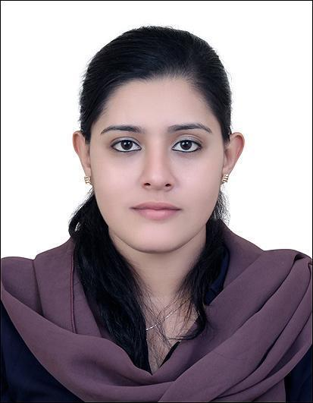**DILSHA NARGHEES P**

**MUWEILAH, SHARJAH**

**Mob: 00971554950998**

**Whatsapp: 00916238096060**

**E-Mail:** [**dilshanarghees1996@gmail.com**](mailto:dilshanarghees1996@gmail.com)

**PERSONAL PROFILE**

A Postgraduate with a comprehensive knowledge and administration procedures and of providing administration and clerical support.

Contribute to the success of an organization by fully utilizing my skills and knowledge that will provide growth in increasing level of responsibility and affiliate with company where my interest, skills and aptitude used to further enhance my qualification and advance.

**QUALIFICATIONS**

* Completed **Hospital** **Administration** from the Institute **ISSD** (International School of Skill Development) which is certified from **TUV** **SUD** and **JainX** University.
* Completed **PG** **MCom.Finance** from Bharathiyar University on 2022.
* Completed Bachelor of Business Administration **(BBA)** from **MES** Kalladi College Mannarkkad, Palakkad (DT)with 75% in a year 2017.
* Passed higher secondary from **MET** English Medium Higher Secondary School Mannarkkad, Palakkad(DT) with 86% in a year 2014.
* Passed high school from **MET** English Medium Higher Secondary school Mannarkkad ,Palakkad(DT) with 80% in a year 2012.

**COMPUTER PROFICIENCY**

* Proficiency in Microsoft Office and Windows
* Tally, Peachtree, Quickbook

**PERSONAL DETAILS**

Date of Birth : 29/02/1996

Gender : Female

Civil Status : Married

Religion : Islam

Languages known : English, Malayalam

Passport No : R1474147

Visa Status : Visit visa

Nationality : Indian

**DECLARATION**

I hereby declare that all the above said details are true and correct to the best of my knowledge and belief.

**Place:** **Sharjah** **DILSHA NARGHEES P**

Date: