DR. NAJMA ABUBACKER PHARM.D

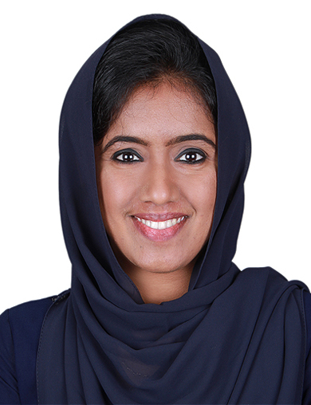DR.NAJMA ABUBACKER

Villa 52, 6c Street Nadd Al Hamar, Dubai,UAE.

**KEY SKILLS & AREAS**

**\***Antimicrobial Stewardship Program

**\***Patient Counselling *ADR Monitoring & using vigiflow

*Medication History- interview

*Dosage Calculations *Drug Information *Drug Interaction Analysis

**PERSONAL DETAILS**

*DOB-23.06. 1994 *Marital status- Married *Place of Birth-Abu Dhabi, UAE

[najmaabubacker288@gmail.com](mailto:najmaabubacker288@gmail.com) Mob:0505565826

**CAREER OBJECTIVES**

To pursue a highly challenging and creative career, where I could apply my existing knowledge and creativity,acquire new skills and contribute effectively to the organization.

**EXPERIENCE**

CLINICAL PHARMACIST

(November 2019 – December 2021)

Amala Institute of Medical Science, Thrissur, Kerala.

* Antimicrobial Stewardship Program.
* Drug interaction checking.
* IP and OP Prescription auditing.
* Drug interaction checking.
* Dosage calculations.
* Adverse drug reaction monitoring &trained in data entry Vigiflow Database.
* Medication Error identification.
* Therapeutic intervention.
* Assisted in preparing Hospital Drug Formulary.
* Preparation of data for NABH inspection.
* Mentoring clinical pharmacist trainees and Pharm D interns.
* Conducted Continuing Nursing Education Programme (Drug Administration errors & Adverse Drug Reactions,Clinical Practice & Pharmacovigilance).
* Assisted faculty members in taking class on pharmacovigilance & Prescription auditing for MBBS students.

CLINICAL PHARMACIST TRAINEE

(July 2019 – November 2019)

Amala Institute of Medical Science, Thrissur, Kerala.

* Antimicrobial Stewardship Program.
* IP and OP Prescription auditing.
* ADR Monitoring and reporting through Vigiflow

**KNOWN LANGUAGES**

**\***English *Malayalam *Tamil *Hindi

**TECHNICAL SKILLS**

*MS Word *Excel *Power Point *Skilled typist

**HOSPITAL TRAINING**

January 2018-December 2018

INTERNSHIP, KG Hopital,Coimbatore,Tamil Nadu

* Ward Round Participation.
* Patient counseling.
* ADR Monitoring and Using Vigiflow.

**PERSONAL DETAILS**

*DOB-24.09. 1994 *Female *Single *Indian **KNOWN LANGUAGES**

**\***English *Malayalam *Kannada

**TECHNICAL SKILLS**

*MS Word *Excel *Power Point *Skilled typist

* Medication History Interview.
* Dosage Calculation.
* Therapeutic Intervention.
* Drug Interaction Analysis.
* Drug Information.

**EDUCATION**

2018|Pharm.D|74.4%|Dr.MGR Medical University| RVS College of Pharmaceutical Sciences,Coimbatore|

2012|12th|76.2%|CBSE|Amal English School, Thrissur|

2010|10th|77%|CBSE|Amal English School, Thrissur|

**CAREER STRENGTHS**

*Adequate knowledge of medicines,their dosages and current standards of practice for planning effective drug therapies.

*Highly gifted aptitude and attention in practicing and research. *Team player, smart worker, quick learner, communicative , admirable commitment and allegiance to work.

**ACADEMIC ACTIVITIES**

Project: ‘’**Incidence of clinically relevant drug-drug interactions in a tertiary care hospital’**

**REFERENCE**

* Dr.R.Venkitanarayanan; M pharm,ph.D,Principal,RVS College of pharmaceutical sciences,Coimbatore,Tamil Nadu. PH:9443064415
* Dr.V K Prathibha;Associate Professor & AMC Coordinator,Department of Pharmacology , Amala Institute of Medical Sciences,Thrissur,Kerala.PH:906125913
* Dr.Padmaja G.Nair ; MBBS MD , Professor & HOD of Pharmacology & Vice Principal, Amala Institute of Medical Sciences,Thrissur ,Kerala. PH: 9895078916.
* Dr.Lejo Jacob; Pharm D,Clinical Pharmacist & Pharmacy Operations,Amala Institute of Medical Sciences ,Thrissur,Kerala. PH:9400426130.

**DECLARATION**

I Dr.Najma Abubacker, solemnly affirm that the above furnished particulars are true to thebest of my knowledge and belief.

Place : Dubai Dr.NAJMA ABUBACKER

Date :