CURRICULUM VITAE

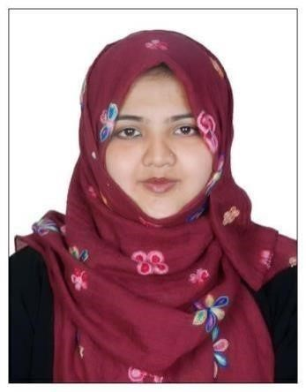

**DR. RAVISH ZEHRA**

No. 406, Building No -2632, Muweilah Commercial, Sharjah, UAE.

WhatsApp / Contact No: +971581922672 Email Id: ravishzehra1214@gmail.com

CAREER OBJECTIVE:

To secure the position as a general dentist in a prestigious organization and utilize my experience to treat and cure the dental problems of patients and be a part of the team to dynamically work towards the growth of organization and gain satisfaction thereof.

EDUCATIONAL QUALIFICATION:

* Bachelor of Dentistry BDS (2007-2012) from MEENAKSHI AMMAL DENTAL COLLEGE – MAHER University

PROFESSIONAL SKILLS:

* Expertise in diagnosis and treatment planning of dental diseases with the help of clinical and radiographic evaluation.

* Good communication skills in creating a rapport with pedodontics and geriatric patients and treating their dental issues effectively.
* Manual dexterity in performing conservative and endodontic procedures like composite restorations, root canal treatment of both anterior and posterior teeth including post and core

* Able to perform prosthetic procedures like removable and fixed prosthesis and smile designing

* Have an immense theoretical and practical knowledge of orthodontics with MBT Technique (SS and ceramic); with a positive feedback of patients on practo.

* A profound expertise in surgical procedures like surgical and non-surgical extraction, frenectomy, etc..

* Performed procedures like full mouth scaling, root planning and gingivectomy.

* Management skills in taking care of the clinic for the growth and upliftment of the organization.

CREDENTIALS:

* Have passed the MOH UAE Exam in July 2019. certificate number- 167531

* Registered dentist in TAMIL NADU DENTAL COUNCIL – Registration number 16450

* Verified dental practioner by Practo.com

ACHIEVEMENTS:

* Have been a general merit student in academics since school days

* Have won first place in the scientific sessions of the national students convention 2011 –IDA for e poster presentation on correction of secondary maxillary deformity

* Secured the second place in LAP QUIZ 2011 (South India level inter college pedo quiz competition)

* Attended pre conference course in post and core treatment in 23rd ISDR conference

* Presented paper on thread pitch vs bone implant interface in prosthodontics at the 23rd national conference of ISDR, Chettinad health city.
* Delivered oral presentation on school dental health in the 63rd Indian Dental Conference, Chennai.

* Presented poster on Drug induced gingival enlargement in the IV National seminar on Basic Medical sciences in Saveetha University, Chennai.

WORK EXPERIENCE:

* Total work experience: - **8 years .**

* Worked as a lecturer in the Department of Oral and maxillofacial surgery in Bangalore Institute Of Dental Sciences college and hospital for a period of 5 months.

* Worked as a general dentist in Profile dental clinic , Chennai for 1 year

* Worked as a general dentist in Dental Nest , Bangalore and handled cases related to dentistry and specialty as well for 2 years

* Worked as a senior dentist at Dr Chahal Aesthetics, Bangalore for 4 Years and a 7 Months. and have managed the clinic single handed in my working shift.

PERSONAL SKILLS:

* Good communication skills
* Good verbal and written communication skills
* Hard work & Punctual
* Strong ability to quickly learn & implement new technologies Have excellent problem solving skills.
* Have basic knowledge of computers and usage of Google sheets.

|  |  |  |  |
| --- | --- | --- | --- |
|  | PERSONAL INFORMATION | | |
| Name  Husband’s Name  Date of Birth  Sex  Marital Status  Religion  Nationality  Languages Known | :  :  :  :  :  :  :  : | Ravish Zehra  Mohammed Ammar  29/09/1989 Female married  Muslim  Indian  English, Hindi, Tamil, Kannada and Gujarati |
|  | DECLARATION: | |  |

I hereby declare that I will be sincere and honest in the entire work given to me and also declare that the information which I have given above is correct and true to the best of my knowledge. If I am given an opportunity in your esteemed organization, I will do my best and excel.

Thanking you, Yours faithfully,

Ravish Zehra Date: Place: