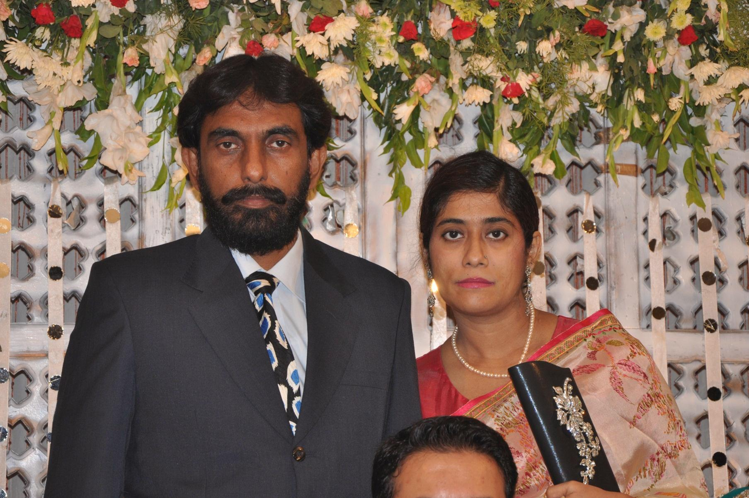

Dr. MAHRUKH MOONA SHARIFF

Cell # +971 562303761Email : moona.sh97@gmail.com

Professional Profile : Experienced Medical professional with over 10 years of experience in General practice & Gynae and Obs, Also extensive experience in Ultrasound Abdomen, Pelvis, TVS, Fetal Vascular Color Doppler.

MOH (General Practitioner) License No: D45667

Career Summary:

1) AJMAN MEDICAL CENTER (POLY CLINIC ) AJMAN, UNITED ARAB EMIRATES

Working as a Full time General Practitioner & a Diagnostic Medical Sonologist

PROVIDE EMERGENCY AND NON EMERGENCY TREATEMENTTO 35 TO 40 PATIENT DAILY

Responsibilities include:

- Administer treatment, Medication therapy and other Medical care to treat patient disease.
- Stitching of Major cut wounds, minor wounds, Abscess drainage
- Provide Pre and Post natal care to the patient.
- Examining patient with Sonography (Ultrasound Abdomen, Pelvis, TVS, Fetal Vascular color Doppler) and other sources.
- DIAGNOSE ALLTYPES OF ACUTE ABDOMEN EMERGENCIES BY SONOGRAPHY LIKE CHOLICYSTITIS,PANCREATITIS,RENAL CALCULI,ASCITES,CYSTOLITHIASIS etc
- Prescribe Medication or specialized care to meet specific patient need.
- Monitor the progress and Current condition of the patient to determine weather current treatment are working or if Modification are needed.
- Collect Patient Information.
- Explain test Result and recommended procedure to patient.

2) FATIMA TRTIARY CARE HOSPITAL PAKISTAN June 2008 to August 2016

Worked as a General Practitioner & Sonologist in Fatima Hospital Gulshan e Iqbal, Karachi

Responsibilities include:

- General Practice
- Normal deliveries with Episiotomies
- Forceps’ vaginal delivery
- D & Es
- Assist in major operations of Gynae and Obs
- Ultrasound Abdomen, Pelvis, TVS, fetal Vascular color Doppler.

3) ABBASI SHAHEED 1500 BEDDED TERTIARY CARE GOVERNMENT HOSPITAL

Worked as a Post Graduate student

Responsibilities include:

- Normal deliveries
- Normal deliveries with Episiotomies,
- Forceps’ vaginal delivery
- D & Es
- General OPD of Gynae & Obs.
- Assist in major operations of Gynae and Obs

4) House job 26th November 1998 to 25th May 1999

Worked as a house officer for Six month in the Department of General medicine Civil hospital Karachi

5) House job 26th May 1998 to 25th November 1999

Worked as a house officer for Six month in the Department of Gynae & Obs Civil hospital Karachi

Training / Certificate:

- Transvaginal Ultra Sound course from Tanveer Zubairi Ultrasound Institute in 2011

Education:
- 9 Month Post Graduate Diploma Course in Basic Ultrasound in the areas of Abdomen, Gynae /
Obstetrics & Vascular Color Doppler Ultrasound from Dow University of College of Physician &
Surgeon (Complete Ultrasound experience requirements of RDMS
Certification)
b) MBBS from DOW Medical College Karachi, Pakistan in 1997
r

Personal Details:

Marital Status Married
Visa Family Status
Nationality Pakistani
Address Flat # 511, Al Zain Tower Opp Sahara Ctr, Al Nahda, Sharjah, UAE

Compiled in November 2018

