Samar Murtada Ibrahim

Ajman, UAE

+971526763193

murtada996@gmail.com

### Experience

8/4/2018 - 15/9/2021

**Medical officer- general practitioner**

Voluntary counseling and treatment center of HIV-aids and TB,

medicine department, Ribat University Hospital.

* Successfully providing full care for patients according to the latest guidelines from the WHO.
* Diagnosis and treatment of HIV-aids and associated complications and related conditions.
* Diagnosis and treatment of Tuberculosis.
* Long term follow up with routine investigations.
* Counseling and mental health wellbeing.
* Provide well referral system for patients as needed.
* Patients medical records registration and filing.

**Housemanship**

Federal Ministry of Health , Sudan

* Surgery - Ribat University Hospital.

2/10/2014 - 30/12/2014

* Medicine - Ribat University Hospital.

6/1/2015 - 9/4/2015

* Pediatrics - Gaafer Ibnauf Specialized Pediatrics Hospital.

16/4/2015 - 27/9/2015

* Obstetrics and gynecology- Saad Abu Alaa teaching hospital.

10/8/2015 - 26-11-2015

29/12/2015 - 29/12/2016

**Medical officer**

Voluntary counseling and treatment center of HIV-aids and TB,

medicine department, Ribat University Hospital

**Languages**

* Arabic: native.
* English: professional level.

### Skills

* Interpretation of Investigations
* Taking different samples
* IV / IM medication administration
* Good clinical skills
* Infection control
* Empathy
* Counseling

### Teamwork and leadership

### Education

2008 - 2013

**MBBS in medicine and general surgery**

Ribat University Hospital

2018 - 2019

**Diploma in family medicine**

Arab institution of continuous professional development

Certificates

17/10/2021

**MOH evaluation letter**

UAE Ministry of Health and Prevention

20/11/2019

**Certificate of full registration**

Sudan Medical Council

2018

**Integrated management of adult and adolescent illnesses**

UNDP-WHO

2018

**Scientific conference**

Sudan association of physicians

2018

**Basic medication safety**

Sudan association of physicians

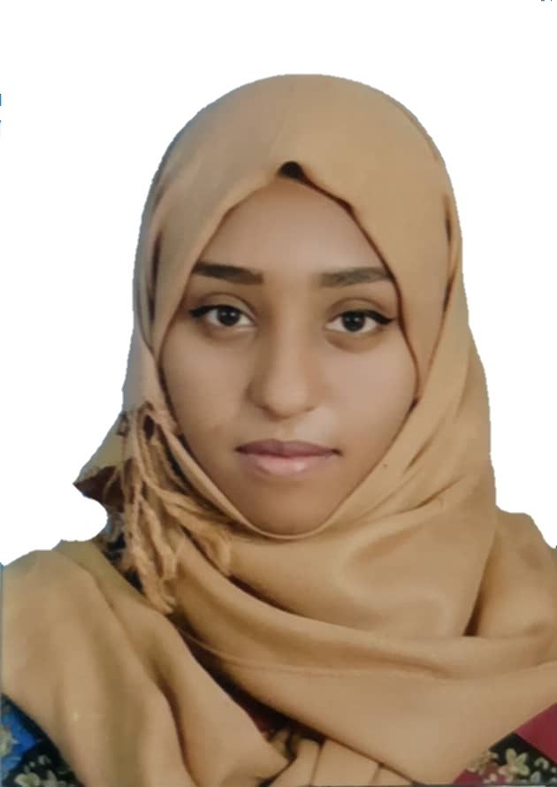

**I am a highly professional caring and compassionate general practitioner with MOH evaluation. I believe in the patient’s right to excellent health service so I always aspire to give my best. I have 4 years of full time experience plus internship witch earned me**

**good clinical and diagnostic capabilities . I am a team leader as well as I am co-operative and respectful of all my colleagues**.