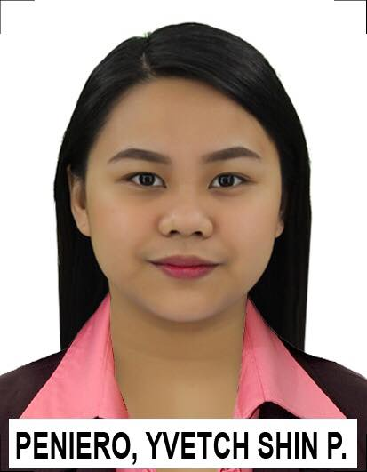

**YVETCH SHIN P. PENIERO**

Barangay Talisay, Barotac Nuevo

Iloilo, Philippines

Mobile: (+63) 9122371308

Email: [yshiinpeniero@gmail.com](mailto:yshiinpeniero@gmail.com)

**OBJECTIVES:**

To become a Medical Laboratory Scientist/Medical Technologist that abides with the standards set by the institution thus, maintaining the quality of the laboratory operations.

**PERSONAL DATA:**

Date of Birth: November 8, 1994

Place of Birth: Antipolo, Rizal

Nationality: Filipino

Religion: Roman Catholic

Gender: Female

Marital status: Single

**EDUCATIONAL BACKGROUND:**

**TERTIARY**

School: University of San Agustin - Iloilo

Degree: Bachelor in Medical Laboratory Science/ Medical Technology

Year Attended: 2011- 2015

**SECONDARY**

School: Saint Paul School - Barotac Nuevo, Iloilo

Year Attended: 2007- 2011

**PRIMARY**

School: Saint Paul School - Barotac Nuevo, Iloilo

Year Attended: 2001 -2007

**LICENSURE:**

A Medical Technologist Board Examination passer last September 2015.

**IDENTIFICATION NUMBER:**

License no.: 0070925

**EXPERIENCE:**

* Clinical training, August 2014 to March 2015 at University of San Agustin and Western Visayas Medical Center.
* A volunteer from November 2015 to June 2016 at Western Visayas Sanitarium, Sta. Barbara, Iloilo.
* Rendered service as Medical Laboratory Scientist from July 2016 to August 2016 at Western Visayas Sanitarium, Sta. Barbara, Iloilo.
* I am a Medical Laboratory Scientist Staff at Our Lady of Peace Hospital, Parañaque City starting from October 25, 2016 up to the present.

**CERTIFICATES:**

* Certificate of Attendance with the topics: DNA Technology in Forensic, Quality Assurance, Customer Satisfaction, QMS Lab Action Plan, and Abnormal RBCs Morphologies.- September 17, 2018
* Certificate of Completion for successfully completing i-STAT Analyzer Training Seminar. – July 28, 2018
* Certificate of Attendance on the “1st Philippines Association of Medical Technologists Free CPD Series for 2018” with the topic: “Quality Improvement in Urinalysis’’ – May 31, 2018
* Certificate of Attendance on 2017 Fourth Quarterly Continuing Professional Development Symposium. - December 17, 2017
* Certificate of Attendance on Quality Improvement Seminar/ Workshop in Clinical Hematology.

– December 11, 2017

* Certificate of Participation on Biological Safety Awareness Seminar. – November 7, 2017
* Certificate of Attendance on Pre-Cycle Orientation-Seminar to the 2017 National External Quality Assessment Scheme (NEQAS) in Clinical Chemistry. – August 16, 2017
* Certificate of Attendance on Disaster Management Seminar. – July 20, 2017
* Certificate of Attendance on the 3rd Continuing Professional Development Seminar for 2017.

– April 26, 2107

* Certificate of Attendance on the Continuing Professional Development Seminar (CPD) with the topics: “Antibody Identification and Screening in Blood Banking’’ & “Understanding Basic Quality Control Principles and Westguard Rules’’ – May 05, 2016
* Certificate of Achievement for successfully completing Operator’s Training on Diatron P500 Fully Automated Chemistry Analyzer. - November 27, 2015
* Certificate of Achievement for successfully completing Operator’s Training on Medica EasyBloodGas Arterial Blood Gas Analyzer. -November 27, 2015
* Certificate of Achievement for successfully completing Operator’s Training on Mindray BC-3600 3 Parts Hematology Analyzer. -November 27, 2015

**INTERNATIONAL CERTIFICATE:**

* Passed the American Society of Clinical Pathologist International (ASCPi) CM on October 11, 2017.

**DUTIES AND RESPOSIBILITIES:**

* Provide quality information for diagnosis and treating diseases.
* Available for all shifts and extended work hours.
* Conduct depth examination on human blood and other specimens by counting and identifying cells, using microscopic techniques and procedures.
* Prepare blood components for transfusions by conducting blood group typing and compatibility tests.
* Operates and maintains sophisticated instruments and equipment used in the division, is able to properly set up, calibrate, maintain, operate and shut down such instruments. Maintains competence in Laboratory Information System that is crucial to the quality operations of the laboratory and patient care.
* Actively participates in Quality Improvement Programs essential to ensure that laboratory testing is accurate, timely and meets customer needs.
* Maintain laboratory supplies inventory by checking stock to determine inventory level, anticipating needed supplies; placing and expediting orders for supplies.
* Maintain safe and clean working environment by complying with procedures, rules, and regulations.
* Protect patients and employees by adhering to infection-control and hazardous waste policies and protocols, following identification procedures.
* Keep and assure confidentiality of examined specimens.
* Contribute to team effort by accomplishing related results in a specified time.

**REFERENCES:**

**MR. ROMAGNE JOHN PALMOS, RMT**

Clinical Coordinator

University of San Agustin

General Luna Street, Iloilo City, Philippines

**MRS. HEGEN ADA GRACE APIADO, RMT**

Chief Medical Technologist

Western Visayas Sanitarium

Sta. Barbara, Iloilo, Philippines

(+63)9951688996

**MS. MARITESS E. SANCHEZ, RMT**

Chief Medical Technologist

Our Lady of Peace Hospital

Coastal Road, Barangay San Dionisio

Parañaque City, Philippines

(+63)9161445357