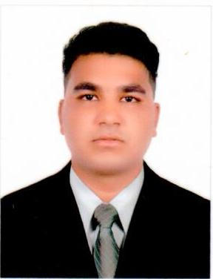**FINHAS JAVID**

**DUBAI – U.A.E**

**Mobile: +971-563014022**

**Email: finhas1javed@gmail.com**

**Carrier Objective:**

My objectives is to be ultimately a better human being which I believe can be achieved by working in an environment involving continuous learning and challenging situation in very friendly and positive manner

**Key Skills:**

* Self Motivation, Excellent interpersonal and communication skills in a professional manner.
* Ability to learn and work under pressure.
* Confident and good team player.
* Ability to deal effectively with multicultural environment
* Good Technical Understanding

**Educational Qualification:**

* Matriculation

**Professional Qualification:**

* Diploma in Medical Laboratory Technician
* Certificate in Basic Food Hygiene

**Computer Qualification:**

* 6 months -Certificate in Computer Application

**Training**

* 2 years-Medical Lab Technician Training in DHQ Hospital, Pakistan
* 3 months internship in Kulsum International Hospital, Pakistan

**Professional Experience:**

* 2 years experience as a Medical Lab Technician in Fathima Medical Centre, Pakistan

**MOH Evaluation Certificate**

Certificate no : 166947

Specialty : Lab Technician

Evaluated as : Medical Lab Technician

Date of issue : 25/11/2018

**Personal Details:**

Date of Birth : 15/07/1995

Nationality : Pakistan

Marital status : Single

Gender : Male

Languages : English, Hindi & Urdu

**Passport Details:**

Passport Number : GV8672831

Date of Issue : 24/01/2017

Date of Expiry : 23/01/2022

Visa Status : Employment Visa

**DECLARATION**:

I hereby declare that the facts given in resume are correct to best of my knowledge and belief.

**FINHAS JAVID**