Gotyba Mohamed Mokhtar

Email: [go0915352502@gmail.com](mailto:aymanmuzamil@gmail.com)

Phone: 0509253633

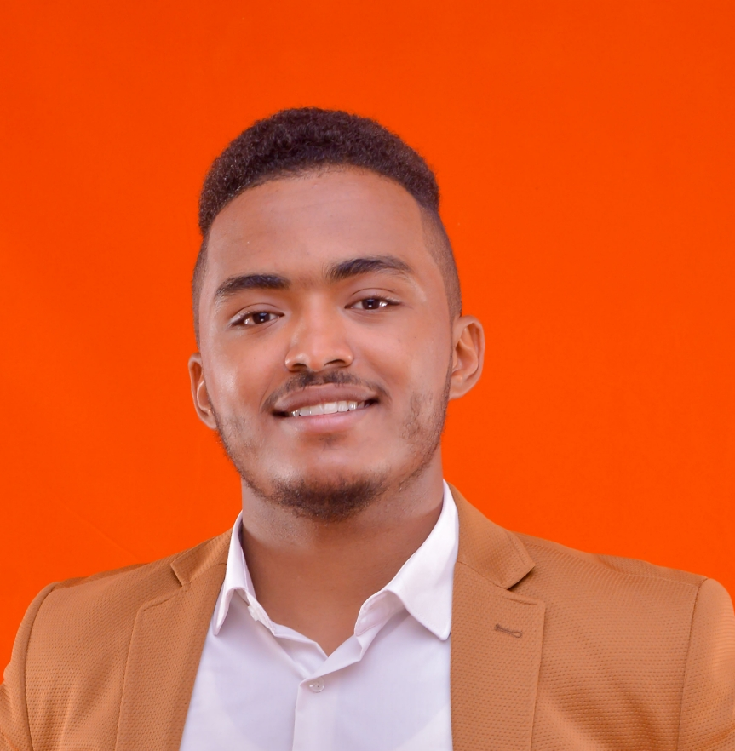

Personal Information

Place & date of birth : khartom-Sudan , 14th-10-1996.

Nationality & Gender : Sudanese – Male.

Religious & Social Status: Muslim – Single.

Current address : Dubai

Education

B. Sc. Honors in Medical Engineering with grade of Second upper Class – Division One. (Top of class)

University of Science & Technology (From 2013 to 2018)

Course

Lamis Comapany ( khartom)

dentile unit Brand ( Ajax)

University of putra (malaysia)

Biomedical robotic lower limb Exoskeleton

Knowledge Skills

* MATLAB.
* Microsoft Office.
* Lab View.
* Electronics.

Experience

* Best care hosbital(sudan)

From 1/5/2018 up to 1/10/2019

Biomedical engineer (sales) &( services)

Joint replacement. (knee replacement) & (hip replacement) & trauma and medical inesterument set

Brand.......

.. (link orthpedics company ,group ortho and pit kar orthopedic )

1-Employed extensive bakground technical knowledg and engineer methodologies to assisst MD through hip &knee replacment surgeries

2-Know about trauma and spine instrument set

3-Collaborated with multsisciplinary specialist to increase sales

4-oversaw several workflow plans to a boost quality and help meets sals target

* Ibn sena hospital(sudan)

2/7/2018 up to 2/2/2019

Biomedical engineer (services)

dialysis machine.Brand............. (gambro model ...95 . 96 and98 ) ,

N medical beds Brand .............( Asco& Hi-tech ) and OR water system Brand ( gambro )

1_conducted daily dialysis maintenance services on time

2-conducted daily quality assurance rounds of the machinessterilization

3-trained medical personal on the appropritae machines use

4_over saw medical beds acquring and maintenance

5-operated and maintained OR water supply unit

Research Interest

* Dental Unit.
* Dialysis machine
* Endoscopy.
* Digital Signal Process.
* Digital Image Process.
* Medical Instrumentation.
* Ultrasound.

Others

* Arabic, excellent (mother tongue).
* English, good.
* came by 3 month visa