**JILSHA.V. P.**

**0563112440** 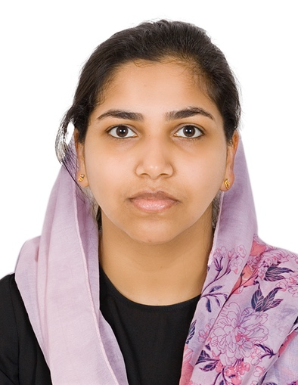

**Jilshashanilvp@gmail.com**

**____________________________________________**

**Objective:**

Confident, dependable professional with wide array of skills and progressive experience in office management. Seeking for the challenging position as a Administrative/Accountant Assistant in the administrative field with opportunity for professional career growth.

**Professional Highlights:**

Excellent administrative and organizational skills with experience in coordinating with customers to resolve their problems. Work under pressure and complete high level workloads within strict deadlines.

**Key skills:**

* Administration
* Customer Service
* Accountant Asst.

**Work History / Job Descriptions:**

Worked as Administration Assistant

Miracle Rubber Industry kerala

(August 2010 to February 2011)

* Handle enquires.
* Successfully organized appointments between employees and clients.
* Responsible for typing reports, memos and other correspondence.
* Seed up the routines of administration and made the filing system more efficient.
* Assigns, reviews, tracks, and prepares correspondence assignments.
* Prepares and reviews agenda materials.
* Reads and responds to correspondence.
* Plans meetings and arrange facility.
* Accepted and distributed messages and mails to proper departments and employees.
* Excellent interpersonal, communication and customer service skills.
* Superb time management skill.

**Educational Qualification**

* Bachelor of business administration, *Calicut university –Kerala (2011) – Completed (2011)*
* Higher Secondary Examination *(commerce) Calicut university-Kerala (2008)*
* S.S.L.C in State Board Of Education – Kerala (2006)

**Computer Proficiency:**

Accounting Packages such as

* MS Office
* Word
* Excel
* Power point

**Personal Vita:**

Marital status : Married

Sex : Female

Citizen ship : Indian

Passport Number : V2158272

Date of issue and expiry : 23-08-2021 - 22-08-2031

Date of birth : 18 May (1991)

Height /weight : 156cm / 55kg

Languages known : English (read, write & speak)

: Hindi (read , writes & speak) : Malayalam (read, write & speak)

: Arabic (read & write)

Visa status : Husband Visa

**Declaration**

I hereby declare that above furnished information is true the best of my knowledge and abilities

Yours Faithfully,

**(Jilsha.V.P.)**