JINSHA MOHAN  DHA ID- 37893543 RN- Registered Nurse  UAE Experience :01 Years 05 Months  Total Experience :06 Years  Department :Medical & Surgical Ward &Emergency | 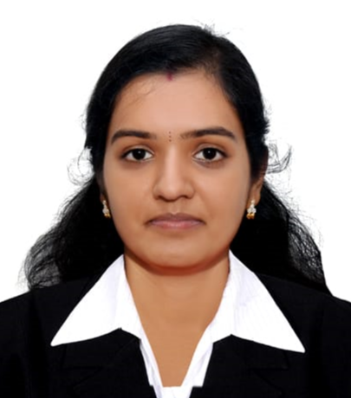
Mobile : +971 52 141 1770  Email : jinshamohan1992@gmail.com  Marital status : Married  Age : 32  Languages : English, Malayalam, Hindi, Telugu, Arabic | Nationality : Indian  Date of Birth : 20- 03-1992  Passport No : V9095294  Visa Status : Resident Visa  Emirates ID # : 784-1992-7553950-2

- Registered nurse with strong experience in delivering quality care to patients. Professional with more than 06 years’ experience including practice in emergency room care, Triage and post-surgical recovery.

- Strong knowledge of medicine, pharmacology and standards of care in the hospital or private practice setting. Caring and reliable person with a reputation for building a great rapport between medical providers and patients. Committed to making patients more informed and comfortable during their care.

PROFESSIONAL EXPERIENCE
Employer | Hospital Capacity | Designation/Department | Year | Duration
Asian institute of medical science, Delhi, India | 425 Bed Hospital | Staff Nurse-  Medical & Surgical Ward | Aug 2015 to Oct 2017 | 2 Years 2 months
Vijaya Super Speciality Hospital, AP, India | 200 Bed Hospital | Staff Nurse-  Emergency | Mar 2019 to Sep 2021 | 2 Years 6 months
Dr.Abdulla's Clinic - Al Qusais- Dubai ,UAE | Clinic | Staff Nurse | May 2023- Sep 2024 | 1 Year 4 months

EDUCATION DETAILS
Course | College | University | Year
B.Sc Nursing | Vijaya College Of Nursing Nellore, Andhra Pradesh, India | N.T.R University, India | 2009-2014
Higher Secondary | TT Thomas Memorial VHSS | Board Of Public Examinations | 2007-2009

Licensure & Certification
- Nursing Registration-Kerala No: KL04202101845
- DHA [Dubai Health Authority] Registered Nurse- DHA –37893543
- BLS [Basic Life Support] American Heart Association – Jan 2027

Reference
Dr.S.V.Krishna Reddy.M.S.,MCh[Uro]
Managing Director - Vijaya hospital, Nellore, A.P

Declaration
I hereby declare that the above given information is true to the best of my knowledge and can be supported by relevant certificates and documents.
Place: Dubai

