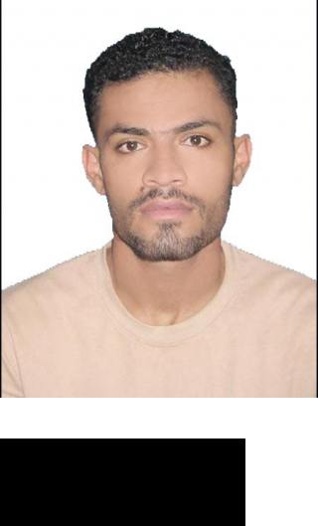

**WORK**

**EXPERIENCE**

**Khalil Nazar**



Al sabkha **E-mail:** khalil.nazar35@gmail.com

Sharjah **Phone:** +971505083666

UAE

Developed Technology

IT HelpDesk Technician Dec 2017 – December 2019

Duties:

Providing technical support over the phone to all IT users.



Handling incoming incidents via the phone / e-mail promptly and effectively.



Diagnosing and resolving a wide range of technical issues over the phone.



Take ownership of a call and seeing it through to closure.



Escalating calls and issues where necessary to senior managers & team leaders.



Investigating and implementing ways of reducing calls to the Help Desk.



Ensuring that all call details are captured and entered in the logging software.



Updating support documentation.



Keeping customers updated as to progress.



Provide troubleshooting and configuration support for client desktop and networking environment.



Sunnay Enterprises Travel and Tours

Customer Service Agent. (Feb - 2016 to Dec - 2017)

Responsibilities:

Coordinate transportation, accommodations, and itineraries for domestic and international trips for clients based on client’s needs, budgets, and expectations.



Develop client intake forms and interview processes that enhance the ability to understand client requirements and led to a 20 percent increase in customer satisfaction.



Network with representatives of hotel chains, airlines, tourist attractions, and other destinations to create deals that saved clients and average of 25 percent per trip. Utilize the latest sales techniques to upsell products and services to enhance client’s overall experience.





**QUALIFICATION**

Intermediate Commerce

|  |  |
| --- | --- |
| From BIEK | (2016) |

IT Diploma 3 years. (2013 to 2016)

From Aptech Computer Education

Matric Science

From New Iqra excellent Sec. School. (2013)



**SKILLS**



**LANGUAGES**

platforms: Windows 10, Mac operating system, Unix, NetWare Servers



applications: MS Office, Norton Internet Security, Bitdefender Total Security, VMware



strong knowledge of LAN, WAN and VPN



solid knowledge of IT Help Desk system



Hardware: PCs, Laptops, Telephony Systems, Printers, Routers, Modems



Networking: LAN & VPN/Remote Connectivity, TCP/IP



Platforms: Windows, Unix, NetWare Servers, Citrix



Browsers:Chrome; Safari; Firefox; MS Edge; IE; SeaMonkey Navigator; Opera



English



Urdu



Balushi



Hindi



2