***NAME:*** *LEMUEL ANYAM ABEY*

***ADDRESS:*** *Sharjah, United Arab Emirates*

***PROFESSION:*** *NURSE*

***Email:*** *abeylemuel@gmail.com*

***CONTACT/WHATSAPP:*** *0581361060*

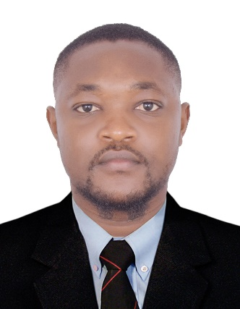

***SUMMARY***

I am a dedicated, diligent, enthusiastic, and compassionate nurse who recognizes the significance of exemplifying the fundamental healthcare principles in my profession. Throughout my career, I have held various roles where delivering exceptional patient-centered care has been the standard practice. As a dependable collaborator, I am capable of taking charge in challenging healthcare scenarios, and my strengths lie in my ability to work efficiently and accurately while adhering to all nursing protocols and procedures. My supportive nature extends to assisting other healthcare professionals in achieving their goals, and I possess the adaptability to tailor my communication and interpersonal skills to meet the specific needs of each patient under my care. Furthermore, I am open to acquiring new professional skills, techniques and the use of modern machinery to enhance the well-being of patients. These qualities make me a formidable candidate for this position. If granted the opportunity, I will tirelessly fulfill my responsibilities with competence, while actively contributing to the continuous improvement, growth, and provision of top-notch treatment and care for the patients of this healthcare organization.

**PROFESSIONAL EXPERIENCE**

**Job Title*:***  *Registered Nurse*

**Organization:** *Regional Hospital Buea*

**Date:** *November 2021- December2023***.**

**Duties**

* Monitored patient health, behavioural and physical changes to improve and update individual care plans and medical needs.
* Carried out various registered nurse duties, including assessment, planning, implementation and evaluation of the patient's condition.
* Supported patients in accomplishing their daily activities and necessities.
* Shared clinical knowledge, skills and experience with junior nurses to achieve competent, high-performing mentorship programmes.
* Kept medical records and documentation regularly updated with accurate, of-the-moment patient data.
* Collaborated effectively with senior clinicians and consultants to implement positive changes and enhance patient well-being.
* Carried out thorough patient assessments, examining physical and mental condition to create strategic programmes of care.
* Observed patient progress, monitoring vital signs and acting quickly upon deterioration to swiftly resolve.
* Educated patients and their families on healthcare plans and procedures.
* Maintained a safe environment when caring for patients, especially those requiring frequent monitoring.
* Provided outstanding clinical care with compassionate emotional support for first-class patient care provisions.
* Provided patients with updates on medical or physical condition improvements or changes when requested by doctors.
* Administered prescribed medication safely and responsibly, monitoring patient progress and adapting doses as required.
* Conducted examinations to determine patient illness or injury, quickly finding problems to create personalised recovery plans.
* Communicated with other colleges on individual cases to resolve patient issues and provide effective solutions.
* Educated the patient and the patient's caregiver about the patient's condition upon discharge and provide guidance on what the patient should and should not do at home to maintain their good clinical state.

**EDUCATIONAL BACK GROUND**

* **BACHELORS OF NURSING SCIENCE (BNS)**

Redemption Higher Institute of Biomedical and Management Sciences (RHIBMS) Buea Cameroon from October 2021-July 2022

* **STATE REGISTERED NURSING DIPLOMA (SRN)**

Redemption Higher Institute of Biomedical and Management Sciences (RHIBMS) Buea Cameroon from October 2018 - July 2021

* **HIGHER NATIONAL DIPLOMA (HND)**

Redemption Higher Institute of Biomedical and Management Sciences (RHIBMS) Buea Cameroon from October 2018 - July 2021

**LANGUAGE**

ENGLISH: Possess excellent English speaking and writing skills.