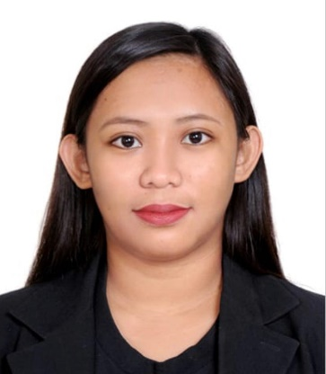**CARREON, MARNETH ANDREA**

Address: Flat 101 Sultan Building, Al Karama, Dubai, UAE.

Contact no.: +97150-4374557

Email: carreon.ollen@yahoo.com

**______________________________________________­­­­­­­­­­____**

**OBJECTIVE:** To acquire a position as a Radiologic Technologist in which the technical, communication, and interpersonal skills and experiences in relation to the said field will be utilized effectively, and learn new skills and develop existing skills with the help of the new experiences that the job may offer.

**PERSONAL INFORMATION:**

**Gender:** Female

**Status:** Single

**Age:** 24

**Birthdate:** February 25, 1995

**Birthplace:** Cauayan, Isabela

**Religion:** Catholic

**Citizenship:** Filipino

**EDUCATIONAL BACKGROUND:**

Special Professional Licensure Examination for Radiologic Technologist (August 2019)

Passed, Board Examination for Radiologic Technologist

Abu Dhabi, U.A.E

2012- 2017 **World Citi Colleges**

Bachelor of Science in Radiologic Technology

College Diploma

2011- 2012 **St. Paul University Quezon City**

Bachelor of Science in Information Technology

2007 - 2011  **Our Lady of Perpetual Succor College**

High School Diploma

2000 - 2007 **Tierra Monte Integrated School**

Elementary Diploma

**TRAININGS AND SEMINAR ATTENDED**

December 2014 **Philippine Association of Radiologic Technologists**

December 2015 **Philippine Association of Radiologic Technologists**

December 2016 **Philippine Association of Radiologic Technologists**

May 2017 **Philippine Red Cross Basic Life Support Training**

**INTERNSHIP TRAINING PROGRAM**

May 2016- October 2016 **Amang Rodriguez Memorial Medical Center**

Junior Internship

December 2016- June 2017 **Armed Forces of the Philippines Medical Center**

Senior Internship

**WORK EXPERIENCE**

September 2017- March 2018 **St. Michael Multi-Diagnostic and Multi-Specialty Clinic**

Medical Receptionist

**SKILLS SUMMARY**

**TECHNICAL/CLINICAL SKILLS**

* Proper patient positioning in general and special radiologic examinations.
* Ability to produce optimal radiographs using proper technical factors.
* Quality assurance and quality control.
* Ability to practice radiation safety and infection control measures, and utmost patient care and handling.
* Capable of records management, film critiquing and multitasking.
* Proficient in computer application such as Microsoft Word, Power Point and etc.
* Works efficiently fast and assuring patient’s safety.
* Ability to adapt to the protocols and new implementations of a procedure.
* Potentially driven to satisfy the needs of the patients and also providing high quality diagnostic images for better diagnosis of the radiologists.
* Flexible in any duty shift.

**CHARACTER REFERENCES**

**Arlene Cordova, RN.**

+971527238185

Hussam Dental Clinic. Al Karama, Dubai U.A.E

Nurse

**Oscar Tetangco, RRT.**

+971552655654

Aster Medical Center, Dubai U.A.E

Radiologic Technologist

**Lemuel Ian Ferreria, RRT.**

+971566775052

Sheikh Khalifa Hospital, Abu Dhabi U.A.E

Radiologic Technologist