**MUEENULLAH.A** 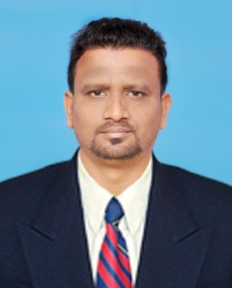

Mobile: +971568683992

E-mail: [mueenullah.mh@gmail.com](mailto:mueenullah.mh@gmail.com)

[inkedin.com/in/mueenullah-alangayam-b0864bb4](https://www.linkedin.com/in/mueenullah-alangayam-b0864bb4)

**Career Objective**

To build a prospective career with my proved ability and skills, highly experienced in reconciling accounts with a high degree of accuracy. Offering a solid foundation in software application, data base management. A fast learner with outstanding organizational and multi-tasking skills, detail oriented with strong ability to work independently.

**Executive Summary:**

* Insurance Verification & Payment Collections.
* MS Office Suite (Word, Excel, Outlook, CRM software)
* Have excellent communication, convincing, negotiation, influencing & interpersonal skills.

**Education Qualification**

Master degree in (**Human Resource)** from ISBM, India Chennai with 68% in the year 2012

**Work History**

**US Medical Billing Company**:-

* **Organization**: **A&A Dukaan Health care services Pvt Ltd, Chennai, India (May 2016 – Dec 31st 2019)**

**Designation: Senior Claims Executive**

**Job Description:**

**Following up with Insurance Companies (HMOs, Medicaid and Medicare) claims Dept to rectify and resubmit old and new unpaid/pending claims along with the required documents. As a senior, managing and updating the new queries, updates to the team member.**

**Roles & Responsibilities:**

* **Responsible for following up with primary, secondary insurance companies based on patient demographic sheet and submit the requested documents to receive the pending payments**.
* **Checking Insurance card numbers, Validity and Insurance plans to minimize the primary rejections.**
* **Checking patient history of visits for the medical details and its appropriateness**
* **Checking for Medical Reports attachments and follow up with the Clinical Documentation Review Specialists for the missing reports to be attached.**
* **Communicate effectively with Clinical Documentation Review Specialists regarding accurate documentation for the approval.**
* **Allocating work queues to the team members and training them with new updates from Clients/providers.**
* **Attending Client meeting along with Team Manager and raising queries to the client for the enhancement of work flow to achieve the deadline targets with minimal rejection rates.**
* **Upon checking the quality of work and giving feedback to each team member for the improvement in quality and reduction of error rates.**
* **Organization**: **Afra Asianray Printing Equipment trading LLC, Dubai, UAE (June 2012 – Aug 2014)**

**Designation: Customer service & Coordinator**

**Roles & Responsibilities :**

* Speaking to customers for the Installation and Service required for the printing Machines and arranging technicians for the Service and installation and follow-up till the job is completed.
* Payments follow-up of services & Sare parts and selling Annual Maintenance Contracts.
* Preparing quotation of print finishing machine processing LPO and Sale order and Coordinating with shipping companies and arranging deliveries of Machines to the customers.

**Achievements:**

* Received compliments by clients and managers for delivering high performance.
* Personal complimentary gifts by management

**Personal Details:**

Date of Birth : 18.04.1989

Religion : Islam

Nationality : Indian

Marital Status : Married

Passport number : U1720078

Visa type : Visit Visa

Languages : English, Hindi, Urdu & Tamil