**Personal Information**

**Contact No:**

054-3227860

055-6350786

07-2289786

**Email:**

[hirakhan78786@gmail.com](mailto:hirakhan78786@gmail.com)

**Father Name:**

Muhammad Tahir Khan

**Address:**

Mamoorah Near Jasia Mosque, Ras-Al-Khaimah, UAE.

**Date of Birth:**

March 02, 1992

**Marital Status:**

Single

**Languages:**

English, Urdu.

**Nationality:**

Pakistan

Dr. Hira Khan 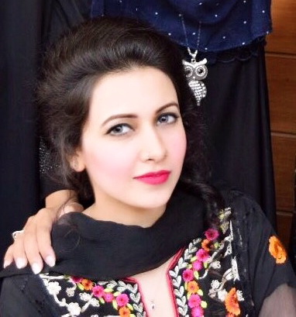

**Pharm-D MOH Licensed**

* **Objective**

Looking for the position of Clinical Pharmacist or Pharmacy Doctor (Pharmacist) in Hospital, Medical Centre & Medicine Industries where highly competent professionals are needed to provide support to nurses and physicians in providing excellent healthcare services to patients.

To build a career which enables to maximize my professional talent and develop my inner potential and contribute my wellbeing towards development of the organization. Strives to enhance the effectiveness and efficiency of all functions for excellence through dedication and commitment in my entire endeavour in a dynamic organization, this would also facilitate continual learning.

* **Research Work**

I did Clinical Research work in Jinnah Hospital & Social Security Hospital. I went to gynaecology ward, Cardiology ward, Neurology ward, Urology ward and Oncology ward to different patients, took their previous histories, detail related to their diseases and the medicines prescribed to them and studied the drug - drug interactions which were worsening the patient's heath.

* **Experience**

2 years training in NMC Royal Medical Center.

* **Participation**

I participate in **"International Pharmacy Conference & Exhibition"**

* **Academic Qualifications**
* **2016 Doctor of Pharmacy with 3.2 CGPA**

University of Lahore (Lahore - Pakistan)

* **2011 FSC - Pre Medical with A GRADE**

Pakistan Islamic Higher Secondary School (Ras-Al-Khaimah - UAE)

* **2009 Science Schooling with A GRADE**

Pakistan Islamic Higher Secondary School (Ras-Al-Khaimah - UAE)

**Skills & Competencies**

**Personal Skills**

Good team player.

Having a flexible approach work.

Remaining calm under pressure.

Non-judgmental.

Able to remain confidential at all time.

Having professional appearance demeanour at all times.

Excellent concentration & Communication skills.

**Competencies**

Ability to prioritise & organise a heavy workload.

Extensive knowledge of medical terminologies, detailed information about medicines and their uses, side effects and contraindications and diseases.

Aware of the rules and regulations relating to medical Field.

**Areas of Expertise**

Dispensing medication

Patient care and support for best treatment.

Clinical expertise

Administration

Health promotion & Customer service

Management of medicines

**Skills & Competencies**

**Personal Skills**

Good team player.

Having a flexible approach work.

Remaining calm under pressure.

Non judgmental.

Able to remain confidential at all time.

Having professional appearance demeanor at all times.

Excellent concentration skills.

**Competencies**

Ability to prioritise & organise a heavy workload.

General knowledge of office procedures and policies.

Extensive knowledge of medical terminology.

Fully aware of infection control policies.

Ability to use spreadsheet and email applications.

Aware of the rules and regulations relating to medical documentation.

* **Reference**

References will be furnished upon request.