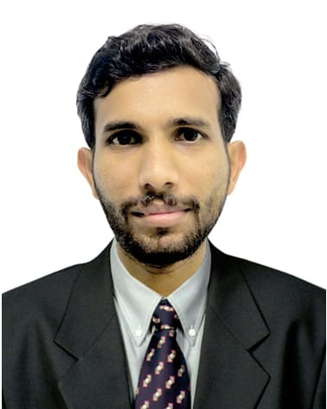

**NITHYANANDAN.P.Y**

Email:[nithyanandanpy@gmail.com](mailto:nithyanandanpy@gmail.com)

Mob: +971-505420396 (UAE) ,+ 91 7293369711( IND)

***CAREER OBJECTIVE***

To obtain a suitable and challenging position where I can utilize Capability and experience so as enable me to grow along with Your organization.

***JOB EXPERINCE***

* Seven Year Experience : Accounts In-charge In a Printing Press (Printing & Packaging Company- Perfume Box making) , Sharjah
* One Year Experienced as an Accountant cum Office In charge in Dr. Wheels, Kerala-India

***RESPONSIBILITIES IN EXPERIENCE***

* Managing the Accounting Department, Including the day-to-day Operations.
* Controlling and Maintaining the General ledger and all related Accounts With Proper Documentation.
* Handling Suppliers & customers for their statement and payments.
* Preparing Payment & Receipt Vouchers and Handling Petty cash.
* Managing Banking Transactions.
* Making Sales Invoice and Supporting Documents.
* Managing Purchase Purchasing section properly.
* Preparing quotation and local purchase order.
* Good communication skill in customer handling.

***EDUCATIONAL QUALIFICATION***

|  |  |  |  |
| --- | --- | --- | --- |
| **Degree** | **University** | **Score** | **Completed** |
| Bachelor of science  (Computer Science ) | Kannur university, Kannur | 66% | May 2013 |
| Higher Secondary Certification Examination | Kerala Higher Secondary Board | 69.66% | March 2007 |
| S.S.L.C | Kerala State Board | 65% | March 2005 |

***ADDITIONAL QUALIFICATION***

* Basic Financial Accounting & Tally (8 months) Course under Account Service Society
* Bsc Computer Science

***SOFTWARE KNOWLEDGE***

* Tally- ERP 9(6.3 Version), MS office, Phoenix MIS, Quick Easy, Peach Tree.

***PERSONAL PROFILE***

|  |  |
| --- | --- |
| Address | Nithyanandan.P.Y, S/o RavindranP.Y, Kasaragod ,Kerala |
| Contact Number | 971-0505420396 |
| Date of Birth | 14th Jun 1990 |
| Gender | Male |
| e-mail id : | [nithyanandanpy@gmail.com](mailto:nithyanandanpy@gmail.com) |
| Nationality : | Indian |
| Known Languages | Malayalam, English, Hindi |

**DECLARATION:-**

I hereby declare that the above-mentioned all information is true to the best of my knowledge.

Place: SHARJAH

NITHYANANDAN.P.Y

+971 50 542 0396