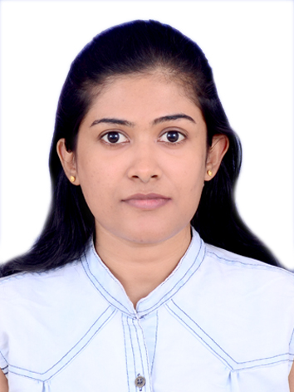**Certified Medical Coder/Auditor**

Nilanka Rodrigo

E -Mail: rodrigo.nilanka@yahoo.com

Mobile**:** +971501395279

**CARRER OBJECTIVES:**

Certified medical coder seeking a position with a reputed organization in medical field

**PROFESSIONAL TRAINING:**

* Certified Professional Coder (CPC) with ICD10
* Advance training in Medical Transcription
* MS office package
* Typing skills of 60 wpm

**TOTAL EXPERIENCE**: 8.6 years (6.6 years medical coding and 2 years medical transcription)

**CAREER ACHIEVEMENTS:**

* Extensive knowledge of medical terminology across a broad range of medical practice areas
* Strong understanding of ICD-9-CM, ICD-10-CM, CPT and HCPCS requirements
* Skilled in abstracting information and assigning codes as per medical record.
* Exposed to multispecialty group facilities.
* Excellent data entry skills with 60 WPM speed
* Excellent oral and written skills in communication
* Good multi-tasking abilities
* Good interpersonal skills and the ability to function as a team member
* Experience with fast-paced medical care environments
* Hands on experience on multiple EMR systmes like Epic, Athena

**EDUCATION:**

Diploma in Nursing, LakeSide Hospital, Kandy, Sri Lanka.

**PROFESSIONAL EXPERIENCE**

**MEDICAL CODING SPECIALIST**

Feb 2012 to Mar 2015 and June2016 to till date: MedSource (Pvt) Ltd, Colombo, Sri Lanka

**WORK DESCRIPTION:**

* Coding for both evaluation and management and surgery medical records on outpatient setting.
* Strong familiarity with coding related to radiology, medicine and laboratory procedures.
* Update providers with medical record necessities for accurate coding.
* Communicate with providers for incomplete medical records and update required information for proper coding.
* Auditing CPT, ICD 10 and HCPCS codes assigned by providers.
* Training and auditing fellow coders and provide feedbacks.
* Preparing quality scores as per organization guidelines.
* Denial handling.
* Collaboration with billing department for reimbursement.
* Achieving productivity goals as a coder and an auditor.

**Medical Transcriptionist/ Quality Analyst**

Feb 2010 - Feb 2012 - MedSource (Pvt) Ltd, Colombo, Sri Lanka

**WORK DESCRIPTION:**

* Achieve given targets daily basis with 98% accuracy adherent to the client specifications guidelines.
* To audit the number of jobs given by the client on a daily basis.
* Record feedback and to let the team know about his/hers' areas of improvement.
* Bring in necessary changes to the process and constant updating of methods of handling work.
* Handling coding denials and communicate with billing teams for relevant information.
* To check whether the team has incorporated knowledge and competence and the customer receives better quality jobs.
* To check if the team has used the right etiquettes and followed appropriate procedures and has given a proper resolution for each and every job processed.

**PERSONAL DETAILS:**

* Full Name : Nilanka Rodrigo
* Date of Birth : 12th June 1985
* Passport No : N5393404
* Nationality : Sri Lankan
* Marital Status : Married

**DECLARATION:**

I hereby declare that the information furnished above is true to the best of my knowledge.