PRAVEENA RAHUL

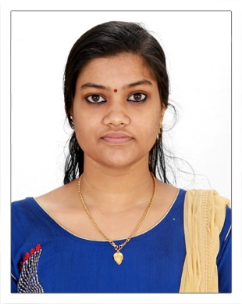

Mob # 00971-562374528

E-mail: [praveenarahul1920@gmail.com](mailto:praveenarahul1920@gmail.com)

Jr. Accountant

**PROFILE** A well organised individual capable to work under extreme circumstances.

Communicates well, both written / orally and enjoys good working relations with a wide range of people. Ideal candidate for position requiring drive, initiative, responsible and challenging.

# EDUCATION

Master’s degree in commerce(M.com)

Bachelor’s Degree in commerce(B.com)

Vocational Higher Secondary(+2)

Secondary school Leaving Certificate Examination(10)

# COMPUTER SKILLS

* MS Office (Excel & Word)
* All common windows software
* I Can handle MS office softwares like Word, Excel & PowerPoint
* I Can prepare Journal, Ledger, Trading and profit and loss account, Balance sheet in Tally prime
* I Can solve all account related problems

# PERSONAL INFORMATION:

Name Praveena Rahul

Husband Name Rahul Gopalakrishnan

Nationality Indian

Birthday 20 January 2000

Religion Hindu

Marital Status married

Sex Female

**LANGUAGES KNOWN**

English, & Malayalam

**PASSPORT DETAILS**

Passport No W1929212

Date of issue 14.07.2022

Date of Expiry 13.07.2032

Place of issue Cochin

**DECLARATION**

I hereby declare that all the information furnished above is correct to the best of knowledge and belief.

Dubai

Praveena Rahul