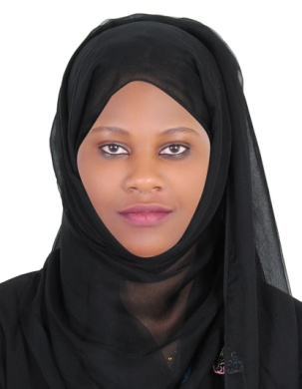

# PROFESSIONAL SUMMARY

I am simple dedicated person , A highly motivated and result oriented professional with over 6 years of experience, capable of performing in diverse and challenging work environment to yield optimal outcomes and I am Avery versatile hardworking, self-motivated, innovative and responsible person who is patient and has good communication skills, good interpersonal skills, team building skills, ability to work with/without supervision, and ability to learn .

# CORE QUALIFICATIONS

* Good communication skills
* Excellent attention to detail
* Caring and sympathetic nature
* Physical fitness
* A flexibility to work
* Ability to work under tight time constraints
* Ability to wok without supervision
* Patience and tolerance

# LANGUAGES

Fluent English and Spoken Arabic

# CERTIFICATIONS

* Basic Life Support [BLS]
* Attested Certified nurse assistant [certification ]
* Certification in swab collection (PCR)
* Caregiver Level 4 [ completion and assessment]
* Recommendations

OLIVER NALUGWA

 +971528437423

 [nalugwaoliver@gmail.com](mailto:nalugwaoliver@gmail.com) Abu hail, Dubai UAE

# EXPERIENCE

# 01/2021 - 05/2022

## EMIRATES HOME NURSING

Certified Nurse Assistant

* Taking vital signs
* Helping with ADLs
* Wound dressing
* Tube feeding and site cleaning and meal feeding
* Turning and moving patient in wheelchair, beds
* Helping the patient in bathing , toileting
* Providing companionship and friendships
* Giving medication and insulin

# 01/2019 - 01/2021

## GHAYA HOME CARE

Certified Caregiver

* Assess and chart observations of the patient’s condition at each visit.
* Complete evaluation tasks, including reviewing medication and vital signs.
* Administer Physician-prescribed medication.
* Dress or redress wounds and assess the healing progress.
* Provide education to patients and families on proper home health care procedures and strategies.
* Coordinate with Physicians, Physical Therapists, Occupational Therapists and other individuals in the patient’s care plan.

# 01/2017 - 01/2019

## SHEIKH KHALIFA SPECIALIST HOSPITAL, RAS AL KHAIMAH

Nurse Assistant

* Moving hospital furniture and electrical equipment
* Transporting clinical waste and dangerous materials
* Taking patients from their ward to consultations and back again
* Giving patients bath and changing pampers + clothes
* Delivering patients' notes to the correct place at the correct time
* Taking dead bodies from operating theatres and wards to the mortuary
* Taking samples to laboratories
* Working on reception in wards

# EDUCATION

2021

## Knowledge Point Institute

diploma in Nursing Assistant: nursing

2020

## fibril training center

JAN-JUNE: nursing 2014

**St Barnabas College** | Kampala Uganda

high school (O LEVEL): sciences

# LANGUAGES

**English, Arabic**: First Language English