PRINCY VARGHESE 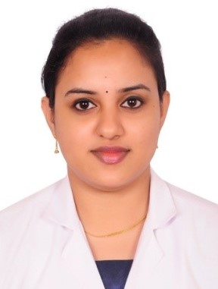
 | AL QUSAIS 2,  Near Al qusais police station  DUBAI, U.A.E

 | +971503674734

 | princyvarghese90@gmail.com

Physiotherapist with DHA ELIGIBILITY LETTER
Accomplished Physical Therapist possessing strong clinical assessment and evaluation skills. Provides supportive environment conducive to addressing individual needs. Distinguished client-facing skills and experience working closely with health care professionals to assess and treat complex conditions. Enthusiastic Physical Therapist offering exemplary patient-sensitivity and years of experience. Knowledgeable in wide breadth of therapies and exercises. Known for keeping patients motivated and dedicated to treatment plans both in and out of therapy sessions.


Skills
 | Trained in motor and cognitive skills therapy

Hands on therapy

Dry Needling Practitioner

Pediatrics knowledge


Work History
2017-07 - 2021-10 | Physical Therapist  AAMRI REHAB INTERNATIONAL, ERNAKULAM, KERALA  - Conducted clinical assessment and evaluation to determine patient needs.  - Planned and administered range of treatments and therapeutic exercise programs involving active and passive ranges of motion and muscle reeducation.  - Researched and stayed abreast of current treatment modalities by attending professional development opportunities.  - Facilitated outpatient therapy for patients with knee and hip replacements, chronic pain and balance disorders.

2014-08 - 2016-09 | Physical Therapist  ST JOHNS MEDICAL CENTRE, ERNAKULAM, KERALA  - Supported patients' progress and physical health by prescribing and demonstrating at-home exercises.  - Taught patients uses of wheelchairs, braces, canes, crutches and prosthetic devices.  - Constructed physiotherapy treatment plans to increase functionality and strength.


Education
2008-09 - 2014-07 | Bachelor of Physiotherapy: Physical Therapy  Medical Trust Institute of Medical Sciences - Ernakulum


Certifications
Certified in Basic Life Support (BLS)

Certified Dry Needling Practitioner

Licensed Physiotherapist with DHA (Dubai Health Authority)

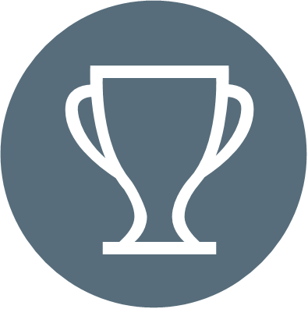
Accomplishments
- Consistently recognized by peers for outstanding achievement in working with children with disabilities.
- Expertly treated more children with neurological impairments, head injuries and mental retardation.
- Trained and oriented new physical therapists and physical therapy assistants.


Software
Microsoft office


Languages
Arabic to speak

English

Malayalam

Hindi

.

