RESUME

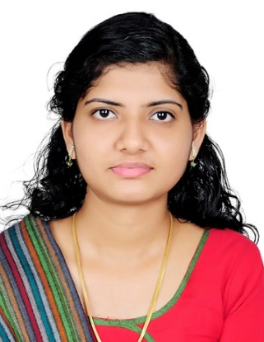

**RAHNA PULCHUR**

Dubai,

UAE

Mob: 0589104065

Email MAIL ID: [rahnapulchur@gmail.com](mailto:rahnapulchur@gmail.com)

**CAREER PROFILE & HIGHLIGHTS**

Responsible and efficient health care professional with proven leadership and customer service skills, a track record of success in implementing company procedures and a solid medication education, poised to offer exceptional support to dynamic health care organisation. Hands on experience obtained via extensive medical education.

**KEY ADMINISTRATIONSKILLS**

* Knowledge of medical terminology, anatomy & physiology.
* Skilled in performing coder duties pertinent to ICD-9, ICD-10 CPT-4 ,HCPCS
* Effective communication, interpersonal and organizational skills
* MS Word, MS Excel. PowerPoint
* Capable to adapt new techniques
* Able to maintain and deliver the responsibilities.

**EDUCATION**

* Certified Program in Medical Coding & Billing - 2018

Cigma Healthcare Academy

Kochi, Kerala

* General Nursing – 2014

St. James School of Nursing.

Chalakudy, Kerala

**HEALTH CARE CERTIFICATION**

⮚ Certificate (AAPC) - CPC Certified Professional Coder

P.T.O

**PROFESSIONAL EXPERIENCE**

Organization: ST.JAMES HOSPITAL

CHALAKUDY, KERALA

Role: Staff Nurse (DIALYSIS)

Duration: 1 year 9 months

**REFERENCE**

**BIBIN BALAN**

Cigma medical coding academy

3rd floor pallipadan highlights building

Edapally-682024

Ernakulam

**Personal Information:**

* Email: [rahnapulchur@gmail.com](mailto:rahnapulchur@gmail.com)
* Contact Number: 0589104065
* Permanent Address:

Thanukkara House, P.O Pullazhy, Olarikkara,

Thrissur, Kerala, India.Pin:- 680012

* Passport Details

Passport No: P2814606

Date of Issue: 25/07/2016

Date of Expiry: 24/07/2026

Date of Birth: 15/06/1993.

* Visa Status : Residence Visa (Husband Sponsorship)
* Sex: Female
* Nationality: Indian
* Marital Status: Married
* Languages Known:

English, Malayalam.

RAHNA PULCHUR