Contact:Rasya  Mobile : 050-5215704  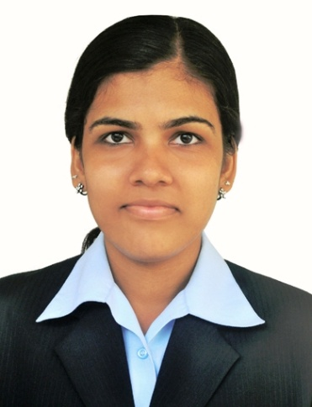  Email :  rasyanireesh.89@gmail.com | CAREER OBJECTIVE  To be a part of a reputed and progressive organization in order to gain  knowledge and assist the professionals in performance of their duties &  responsibilities for achieving their goals and objectives efficiently& effectively.  PERSONAL INFORMATION  Full Name: Rasyamol AR  Qualification: B.Com & MBA  Specialization: Finance, Administration & HR  Experience: 2 Years in Admin and Finance.  8 months of experience from INDIA as KG Teacher  Passport No: H6283920 valid up to 2020  Visa Status: On Permanent Residence Visa.  Nationality Indian  Date of Birth December 7th 1988  Languages English, Malayalam & Hindi  Hobbies Dancing & Cooking  Computer Knowledge  - Full knowledge of Computerized Accountingi.ePeachtree, Quick Books and Tally.  - Proficient in ERP-INFOR.  - Proficient in Microsoft Office.  - All Windows editions.  - Internet browsing, surfing and emailing.  PROFESSIONAL EXPERIENCE  1) Employer: SKM Air Conditioning LLC, Sharjah  De Designation: Finance Team Member (Accounts Payable)  Duration: (Jan 2019 to March 2019 – On 3 month Temporary Vaccancy)  Major Responsibilities  - Process Invoices, Purchase Orders and Credit Notes through ERP Software and charge them to their respective codes.  - Bank Reconciliation: Prepare monthly bank reconciliation for bank accounts, research and resolve reconciliation discrepancies and prepare adjusting journal entry to correct the appropriate general ledger accounts.  - Processing Reversal entry and Correction entries after identifying the wrongly passed journal entry.

2) Employer: Bab Al RahmaneyaTechnicalContracting Co.
Designation: Accountant Cum Administrator
Duration: Feb 2017 to July 2017.
Major Responsibilities
- Preparation of Financial Statements i.e. from General Entry to Ledgers, Trial Balance, Profit & Loss account and Balance Sheet.
- Preparation of monthly statements as per the company requirements.
- Preparation of supplier’s accounts (purchase order, purchase bills).
- Preparation of Quotations and making negotiations for the final rate of work and preparing purchase orders.
- Responsible for issuing cheque to suppliers.
- Documenting the company staffs details and preparing the payrollaccounts.
- Documentation of company details and other work related documents.
- Responsible for collecting bills and maintainingdaily records.
- Responsible for the supervision to make communication link with clients.
- Making arrangements for Site meetings and management of all site personnel.

3)Employer: Mediapro International LLC
Designation: Accounts Assistant
Duration: 3Months
Major Responsibilities
- Collecting data fromvarious sources.
- Maintenance of records
- Analysis of raw data.
- Preparation of supporting books whichuseful to preparefinancialstatements
- Sales/ invoicing, account receivables & all other related reports.

Employees’ payrolls and payments to vendors.

4)Employer Aptara Learning Private Ltd, Trivandrum.
Designation Financial Analyst.
Duration 2 years (March 2012 to Feb 2014)
Major Responsibilities
- Analysis of financial statements i.e. Balance sheet, Income statement, Cash flow & so on created under consideration of US GAAP & making them ready to be filed on SEC (Securities Exchange Commission) on regular filing intervals in XBRL (Extensible Business Reporting Language) format after adequate normalization on the basis of recurrence and non-recurrence of items by utilizing US GAAP taxonomy.
- Ensuring that financial reporting document (10-Q, 10-K, and 20-F) is standardized as per the compliance/reporting rules set by Securities Exchange Commission & ensuring the quality of the deliverables to client.
- Solving technical issues arise during the validation process such as validation errors on Mandate level of SEC pre filing report viewer & making the financial reporting document ready to be filed in the SEC after technical clean ups.
- Delivering the final reporting document to client under specified time frame keeping quality standards intact.
- Quality check and control

QUALIFICATION (Detail)
Degree | Major/ Specialization | Passing Year | College & University | Marks %
MBA | Finance/ HR | 2011 | Holygrace Academy  Calicut University | 67
B.com | Income Tax & Accounts | 2009 | Vivekananda college Calicut University | 72
Commerce  HSE | Accounting | 2006 | LF Convent  State Board | 85

Declaration: The information furnishedaboveis correct to the best of myknowledge.

Date: Rasyamol AR

