HOSPITAL ADMINISTRATOR/QUALITY/HUMAN RESOURCE MANAGER
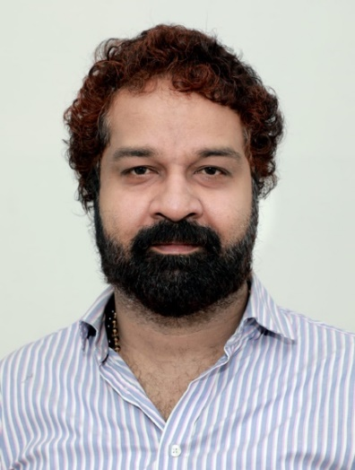 | REMYL YESUDAS  Cell No: +91 98950 60606 (Global Access No)  Email : remylyesudasgp@gmail.com  linkedin.com/in/remyl-yesudas-a6b524333

Objective: To pursue career in a reputed hospital and thereby impart professional expertise for its progress by augmenting patient care with adherence& compliance to established standards and be specifically instrumental for the development of that hospital.

Academic Qualifications:
M. H. A (Master of Science in Health Care and Hospital Management)
From Christhu Raj College affiliated to Bharathidasan University, Trichy.
A Professional Post Graduation Degree with department placements at various renowned hospitals. Exposed to resourceful sessions related to Hospital Administration, Human Resources/Quality Management, Patient Relations& Business Development as part of the curriculum.
Passed with First Class (70% Aggregate)
Major Thesis was done on the topic “A Study on need of establishing Geriatrics Specialization at a Hospital”
B. Com; Graduate in Commerce from University of Kerala. (With Tourism and Hotel Management as optional subjects)
Technical Qualifications: Diploma in computer applications i.e.,
Exposed to all data entry modalities such as Dos, Window, MS-Word, Excel, Access, PowerPoint, FoxPro,
Desktop Publications such as PageMaker & Corel Draw, Business Applications, Tally etc.

Strengths: Ability to take up high risk &responsibilities, Good conversational and writing
skills, Assertive and Confident to handle and tackle different situations.

Language Proficiency: Rated ‘Good’ for National English Language testing service conducted by Central institute of English as foreign language, Hyderabad, India.

(P.T.O.)

WORK EXPERIENCE:

ASSOCIATE HOSPITAL ADMINISTRATOR/QUALITY& H. R. MANAGER of Bishop Benziger Hospital for a span of around 17 years
Job profile Spearheading with the Head of the Institution.
Creative Contributor in hospital policy making &
Team leader responsible for executing the policy decisions.
Conferred as the 'Power of Attorney Holder' of the Management.
In the beginning of the career constituted a Human Resources Department after a thorough scientific study by submitting a project report. Overall responsibility of HR paradigms is vested since then. Other jobs include Supervision & Coordination of Reimbursement/Insurance dept by facilitating new health insurance schemes, Dealing with all Legal &Labor issues. Possessing Credit of Victory by way of advocating the management by appearing in person at labor court. Streamlined the Materials management department by implementing scientific purchase/procurement procedure.
Conducting HR Interviews, Domestic Enquiry Proceedings, Formulating & Implementing Public Relations, Media Relations & Patient Relations Programmes , handling external affairs, Liaising with bureaucratic machinery, Correspondence through letters, circulars, group discussions, preparation of comprehensive minutes and annual reports. Organizing Health Event Medical Camps, Performance Appraisal Management. Conducting Seminars &Academic Presentations, implementing updated guidelines quality accreditation procedures in all departments by furnishing its protocols and documentation procedures. In-charge of documentation for obtaining all the mandatory licenses and permits. Hitherto privileged of being appointed as the Honorary Secretary of the Ethics Committee/Women Cell. Amassed revenue for the organization by way of marketing advertisement for Community Radio Benziger, i.e., the FM Radio functioning within the hospital. Introduced new clinical departments, facilities & technologies. With umpteen other practical knowledge and confidence in handling legal issues. After undertaking additional responsibility as QUALITY MANAGER, the hospital attained the prestigious NABH Pre-Accreditation accorded by the Quality Council of India.
Worked from July 24 2006 till December 27, 2022
- Administrator of Valiyath Institute of Medical Sciences

Hospital Administrator of Upasana Hospital.
The vested responsibilities as a Hospital Administrator pervades the overseeing of day-to-day operations of the hospital and chief strategist for the hospital development &policy maker for augmenting patient care, patient safety as well the patient strength.
- Administrator of First Computers Responsible of controlling the staff and students, implementing marketing activities, assessment of accounts etc.

DETAILS OF IDENTITY:
Passport: Given Name – Remyl Yesudas; Passport No. P0430889.Date & Place of Issue – 26/08/2016,
Trivandrum.
Driving License: Driving License Number – 2/3613/1994. Valid from 04/06/1994 through 26/12/2025
Identity Card of Election Commission of India: KL/18/124/180432,
Aadhaar No: 7282 9543 0616
Pan No: AHQPY9799M
Reference: Fr. Ferdinand Peter,
Director Emeritus, Bishop Benziger Hospital, Kollam, Kerala, India.
Tel: +91-9744722299
REMYL YESUDAS
Place : India
Date : 21/11/2024

