**RESHMA KABIR** 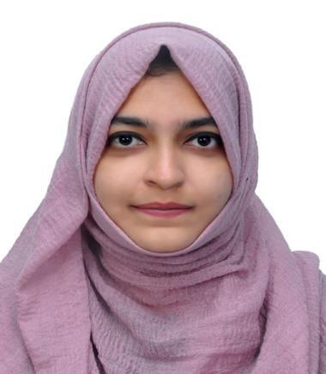

**Mail ID: talktoreshh@gmail.com**

**Mobile No: 971526093209**

_________________________________________________________________________________________________

# Professional Summary

* Highly effective dietitian with 2+ Years’ experience working in various aspects of the health field offering array of skills in clinical assessments, patient counseling, nutrition education, employee supervision, managing administration, team building and cultural competence. Track record of success resolving issues using logical approach in a dynamic environment. Now looking forward to a successful career by working for a reputable organization.

# Work Experience

* **Oxymed Hospital Private Limited, Chennai**– Dietitian

From June 2019 – May 2023

* **AG Cars services, UAE** – Administrative Assistant

From Aug 2023 - Current

# Educational Qualification

* Food Technology and Management, 2017-2019 - Madras University (P.G)

* Home Science with Food Biotechnology, 2014 - 2017- Madurai Kamaraj University (U.G)

* Regional Centre for Training and Development- Training in Montessori Education -2016 (Diploma).

# Technical Skills

* Dietitian:
  1. Dietary consultation (off-line, on-line).
  2. Nutritional assessments.
  3. Diet plan preparations.
  4. Diet based modifications.
  5. Database management (Modoc app).
  6. Good interpersonal skills.

# Rewards & Recognition

* Received ‘Stars’ for best employee award in monitoring diets for Corona Patients during Pandemic.
* Received ‘Badge’ for monitoring cancer patient’s diet.

# EXPERTISE & SKILLS

* Good knowledge in food sciences and safety standards.
* Helped in managing the diet plans based on the non-invasive treatment for heart diseases.
* Provided one to one weight loss coaching and mentoring
* Meeting individual needs with a positive approach.
* Serving as a consultant to hospital staff, medical personnel, patients, families, students regarding dietary management.
* Planning diet based on Food and drug interaction/food allergies.
* Experience in sea food quality assurance and export documentation.
* Expertise in office management skills.
* Having good exposure in client handling techniques.
* Having good administrative skills.

**Work Summary**

# Oxymed Hospital Private Limited, Chennai

* Role : Dietitian

**Responsibilities:**

* Performed detailed and individualized nutritional assessments and focused on critically ill population (cardiac, diabetic, carcinoma, hypertensive, ortho, renal and covid).
* Collaborated with doctors to understand medical conditions and dietary restrictions of patients.
* Provided therapeutic diet counseling for patients and their family members from most current recommendations by reviewing current diet order, laboratory data and medical diagnosis.
* Attended ward rounds for In-patients to know their health conditions and modify dietary needs.
* Recorded monthly and quarterly Diet progress notes for both In and Out-patients.
* Plan diet food individually and conduct quality assurance by supervising the preparation and serving food at mealtime.
* Prescribed therapeutic diet in discharge summaries based on RDA calculation.
* Camp based online nutritional educator for college students and Montessori trained Teachers.

# AG Car Services , UAE Sharjah

* Role : Administrative Assistant

**Responsibilities:**

* Handling customer services via phone, email or in person addressing their questions and resolving their issues.
* Maintaining client information, policy details and claim records into the company's database accurately.
* Prepare, organize, and maintain insurance documents, policy files , and correspondence. Ensure all documents are correctly filed and easily accessible.
* Providing general administrative support to manager, other co-workers which includes preparing reports, managing cash , handling correspondence.
* Ensure that all the administrative processes comply with company policies and regulatory requirements.
* Liaise between clients , other departments to ensure smooth communication and efficient operations.
* Oversee office operations maintaining, organizing workspaces and handling mail and deliveries.

## PROJECTS

* 2019 – Research on oil absorption capacity of fried foods by coating aloe vera(reverse absorbent).
* 2018 - Evaluating the shelf life of biscuits - Britannia Pvt. Ltd- Bangalore.
* 2017 - Dietetics internship - Meenakshi Mission Hospital - Madurai.

## 

## PERSONAL DETAILS

* Date of Birth : 27-07-1997
* Nationality : Indian
* Marital Status : Single
* Passport No : T2160749
* Visa Status : Employment visa
* Languages : English, Urdu, Hindi, Tamil