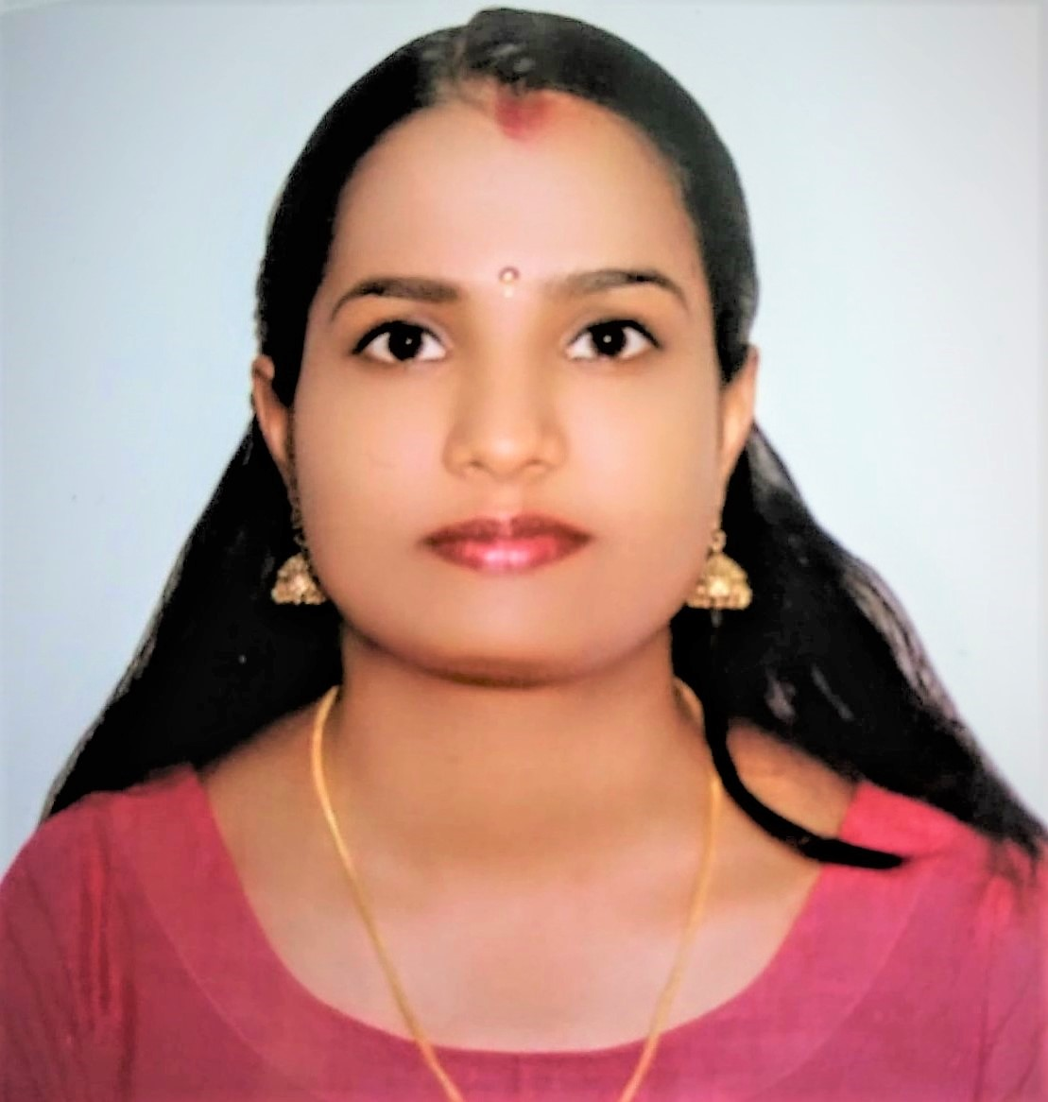

**RESHMA T NAIR**

**AJMAN, UAE**

**MOB: +971 505 751368**

**TEL: +971 6 5646734,**

**Email: reshmadhileep@gmail.com**

**OBJECTIVE:**

To obtain a responsible and challenging position in a professionally managed organization. I am looking forward to an opportunity where I can utilize my knowledge and skills gained so far in contributing effectively in the growth of your esteemed organization and also to further improve my personal skills and knowledge by being a part of a professional, dedicated and hard working team.

**SUMMARY OF BACKGROUND :**

Passed MOH Technologist Biochemistry exam ( **License Number : T38312** ) and Experience and work history encompasses a total of 6 plus years in the field as Clinical Biochemistry Technologist cum Lab Technician, where I had good exposure to latest biomedical equipments.

**SKILL HIGHLIGHTS:**

* Specialized in Biochemistry
* Skilled in medical lab technician tasks including sample collection, analysis and lab report production.
* Well versed in laboratory software.
* Track records of collaborating with pathologists and physicians regarding test results and analytical patterns in blood reporting.
* Knowledgeable of medical lab policies, hygiene requirements and general procedures.

**PROFESSIONAL EXPERIENCE:**

**1.JOB TITLE : CLINICAL BIOCHEMISTRY TECHNOLOGIST**

**Mampilly Medical Center, Sharjah, Rolla as Clinical Biochemistry Technologist from 15/03/2015 to Present**

**KEY DUTIES/RESPONSIBILITIES:**

* Analyzed tests in areas including biochemistry, hematology , urinalysis and serology to aid physicians in diagnosing and treating disease.
* Evaluated quality control within laboratory using standard laboratory test and measurement controls.
* Performed and noted down clinical laboratory tests accurately.
* Maintain accurate records according to laboratory policy.
* Analyzed and evaluated lab results with relevant QA data.
* Result verification and its reporting at its right time.
* Recording data of the patients.

**2. JOB TITLE : BIOCHEMIST**

* **M/s Thottingal Computerized Lab, X-ray, Ecg, Scan    ( USG) Chittur, Palakkad, Kerala**

**1 Year exp. As Biochemist.(1/5/2012 to 20/5/2013)**

**KEY DUTIES/RESPONSIBILITIES:**

* Collection of blood samples.
* Evaluate test results and analysed samples during tests
* Performed and noted down the clinical tests accurately.
* Maintained accurate records according to laboratory policy.
* Assisting in running qc programmes in analyser.
* Result verification and its reporting at its right time.
* Recording data of the patients.

**EQUIPMENTS USED:**

* Accurately recorded and reported test results according to established procedures.
* Performed highly complex tests on clinical specimens for diagnostic purpose
* Expertise in handling modern equipments:
* **Semi auto analyzer**
* **Automated** **Biochemistry analysers** – **CHEMWELL T, ERBA XLM 200 ,AGAPPE MISPA NANO**
* **Automated 5 part** **Hematology analyzer: NIHON KOHDEN CELLTAC ES**
* **Automated 3 part** **Hematology analyser** : **MINDRAY**
* **Dry Chemistry analyzer**: **REFLOTRON PLUS**
* **Hormone analyser: MINIVIDAS , MINDRAY CL 900i**
* **Mispa-i2 Nephelometry analyser**
* **Afias 6 flurescent immunoanalyser**
* **Nycocard reader II**
* **Urine Chemistry analyser : CLINITEK**
* **Electrolyte analyser : ERBA LYTE**
* **Care sure Analyser 100**

**EDUCATIONAL QUALIFICATION :**

**MSc. In Bio-Chemistry,** Calicut university, Kerala, India (Calicut University Campus)

B.Sc. Biochemistry , Calicut University, kerala, India (Sree Krishna College, Guruvayoor)

**PROJECTS UNDERTAKEN**

Antimetastatic Activity Of PSM001 On A549 Lung Cancer Cells ( Regional cancer center, Trivandrum)

**CONFERNCES ATTENDED:**

**State level seminar and workshop on biological techniques organized by the dept of microbiology, biochemistry and biotechnology at Marathanasius College Kothamangalam on 21, 22 and 23 Nov 2009**

**RESEARCH AREAS INTRESTED**

* **Cancer biology**
* **Molecular Biology**
* **Plant Biochemistry**
* **Enzymology**

**SOFTWARE SKILLS:**

**Diploma in Computer Application (DCA)**

**LANGUAGE’S**

**English**

**Malayalam**

**Tamil**

**Hindi**

**PERSONAL DETAILS:**

**Date of birth: 14th January 1989**

**Gender: Female**

**Marital Status: Married**

**Visa Status: House Wife**

**STRENGTHS:**

* **Dedicated & Hard working**
* **Reliable & Disciplined**
* **Commitment & Team work**
* **Optimistic**
* **Balance between Time & work**

**REFERENCES**

**References available upon request**

**DECLARATION**

**I hereby declare that the information furnished above is true and the best of my knowledge.**