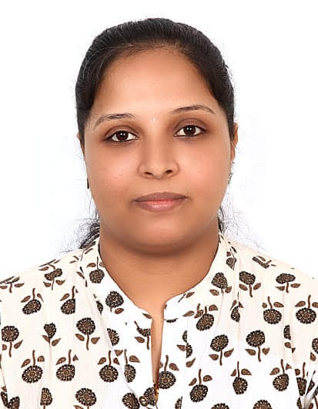**R****ESHMI RIJU**

**Medical Microbiology technologist MOH Ref. No:283474**

Microbiology technologist/ Medical laboratory technologist with over 6 years of experience in Microbiology, Clinical pathology, Hormone analysis, Hematology seeking a position in healthcare setting.

**LinkedIn Profile :**[**https://www.linkedin.com/in/reshmi-riju-4156b977**](https://www.linkedin.com/in/reshmi-riju-4156b977)

**Email: -** [**reshmipkm@gmail.com**](mailto:reshmipkm@gmail.com) **Mobile No:- +971 555719489, +971528494541** Muweillah, Sharjah, UAE

**EDUCATION PROFESSIONAL AFFILIATIONS:**

**Msc Microbiology MOH evaluation letter holder:**

Bharathiar University,India Medical Microbiology technologist:

Ref. No: 283474

**PROFESSIONAL EXPERIENCE KPMTA**

**Primacare Specialty Clinic LLC** MEMBERSHIP NO:157/02/03/18

Bur Dubai, Dubai.

***1/02/2023-15/04/2023* PERSONAL SKILLS**

Designation: Laboratory technologist Computer skills, excellent communication

Duties Performed: skills, good teamwork ,ability to work under

Microbiology, Hematology Clinical pressure, maintains positive relationship

Hormone assay etc. with other staffs, problem solving skills.

Knowledge about ISO-15189, DHA policies***.***

**AMC Hospital, Kerala, India EQUIPMENTS HANDLED**

Designation: Microbiology technologist Autoclave, Hot air oven, LAF,

***15/01/2021-20/01/2023*** incubator, waterbath,Mispa i2, Bactec2020,

Sysmex Mindray, Elisa reader.

**Nitya Medical Laboratory, Kerala, India**

Designation: Microbiologist & Lab technician **DUTIES &RESPONSIBILITIES**

***05/03/2018-30/11/2020*** Quality assurance, Quality Control

Work accordance with SOPs, safety

**Dhanalakshmi Hospital, Kerala, India** management( wearing PPE)

NABH Accredited Multispecialty hospital waste disposal management

Designation:Senior Microbiologist recognition of out of control values,

**(Microbiology dept Incharge)** critical value monitoring,register

**11/06/2016-14/10/2017** maintenance

Duties Performed: following proper guidelines while working

Work accordance with hospital policies, with category 3 organisms.

patient safety goals, specimen processing( urine , sputum, stool,

Infection prevention control programs suction tip, bronchial washing,pus)

Monitoring resistant pattern of organisms, gram staining, AFB staining, media

(Nosocomial infections, ESBL, MRSA) preparation, ABST technique, KOH Mount,

Critical test result management, LPCB method, slide culture, fungal culture,

Needle stick injury reporting, examination of stool samples for ova/ cyst,

Participation in CQI/ CQM management performing card tests, stock register

Antibiogram preparation maintaining, knowledge about automated

Blood culture system.

**KANNUR MEDICAL COLLEGE HOSPITAL, INDIA LANGUAGES KNOWN**

Designation: Microbiologist & Lab technician English, Hindi, Malayalam, Tamil

***10/09/2013-10/11/2015***

**Visa status: Husband Visa Personal Data   
Passport Details: DOB : 17.04.1989**

**Passport no: P 9892678 Gender: Female**

**Date of expiry: 18.06.2027 Nationality: Indian**

**Reference**

1.Dr. Gufran Ahmed- HOD at Kannur Medical College Super Speciality Hospital, Kannur, Kerala

Mail id: [gufranbijapur@gmail.com](mailto:gufranbijapur@gmail.com), Contact : +919995356567

2. Elikutty Mathew- Laboratory incharge at Dhanalakshmi Hospital, Kannur, Kerala

Contact :+919745658607

**Declaration**

I hereby declare that all the above furnished details are true and correct to the best of my knowledge.

RESHMI RIJU