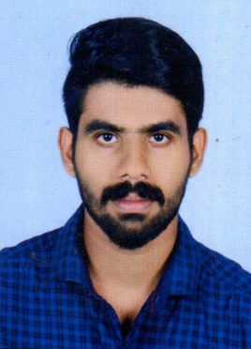***SAMEER K SALI***

***Mob: +971-523240679***

***Sameerksali007@gmail.com***

***Abu Dhabi***

***United Arab Emirates***

***Summary***

*To serve in your progressive organization offering a challenging environment and vast opportunities for career development based purely upon achievements and results. I seek a challenging career that gives me a chance to prove my technical. Intellectual and managerial abilities. Polishes my skills and ads to my professional achievements*

***Personal details***

* ***Nationality : India***
* ***Date of birth : 10/05/1995***
* ***Gender : Male***
* ***Marital status :Single***
* ***Religion : Muslim***
* ***Languages known :English, Hindi, Malayalam***
* ***Visa Status : Visit Visa***

***Work Experience***

***Worked with Vaipur Service Co-Operative Bank LTD A.203***

***As a Banking***

***Vaipur, India***

***1 year***

***Job Responsibilities***

* *Handling & Maintaining Accounts Up to Finalization*
* *Reconciliation of : Bank, H.O , Branches, Debtors, Creditors, and Stock*
* *Ledger Scrutinization, Analysis of Trial balance, P & L and B/S.*
* *VAT Computation, Return Filing,*
* *Control Over All Accounting and Financial matters*
* *Monitoring of daily business activities*

***Skills***

*• Strong analytical and problem solving skills.*

*• Positive thinking and hardworking*

*• Ability to deal with people diplomatically.*

*• Good organizational skills.*

*Computer Knowledge*

* *Operating System –Win7/Win8/Win10*
* *Office Packages­­ – Microsoft word, Excel, MS Office ,Tally ERP 9, Peachtree , Quick books*

*Education Qualification*

* ***MBA Annamalai University***

***Subject: Financial Management***

* ***B.Com Co-Operation in MG University***

*Passport Details*

* *Passport No : N9534573*
* *Place of Issue : Trivandrum*
* *Date Of Issue : 15/06/2016*
* *Date Of Expiry: 14/06/2026*

*Declaration*

*I Hereby Declare That All above Furnished Information Are True and Correct To the Best of My Knowledge*

*SAMEER K SALI*