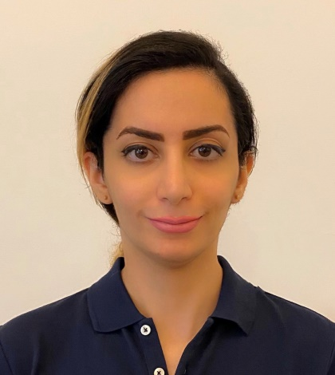

Curriculum Vitae

Personal Details

* Name: Fatemeh Hosseini
* D.O.B: 21 , september , 1985
* Nationality: Iranian
* Visa status: Under Father’s sponsership
* Address: jumeirah 1, Dubai ,United Arab Emirates
* Gender: Female
* Email: samira.hoss64@gmail.com
* Mobile: 00971559521421

Skills and Language

* Persian (Farsi): Native Language
* English: Fluent
* Arabic: Intermediate
* Computer Skills: Microsoft office , Dentimax software , Dentrix software

Qualifications

* Dental Degree : D.D.S at Ajman University of science and technology , United Arab Emirates , conffered date : 2013
* DHA license, conffered date : 2017

Dental Skills

* Skilled in root canal treatments
* Bleaching and whitening techniques
* Composite and amalgam restoration
* Patient management and care
* Extractions and minor surgeries

Working Experience

* Dental training program-Ajman university of science and technology , , , ,UAE , (sept 2013)
* A one year training program (Internship) consisting of rotations through the different dental specialities and included a number of theoretical and clinical parts, Ajman University ,UAE , (sept 2014-sept 2015)
* A clinical volunteer work at Ajman University of science and technology , UAE , (february2016)
* One year volunteer work in Fereshteh Royal Dental Clinic, Iran, Tehran , (feb 2017)
* working as a dentist in panorama medical centre ,Dubai ,UAE,

(august 2018- april 2020)

Workshops Conferences

* Attended the uae international conference "AEEDC" (february 2015)
* Attended the 1st dental symposium organized by SGH-dubai educational and training committee (november 2014)