Curriculum vitae
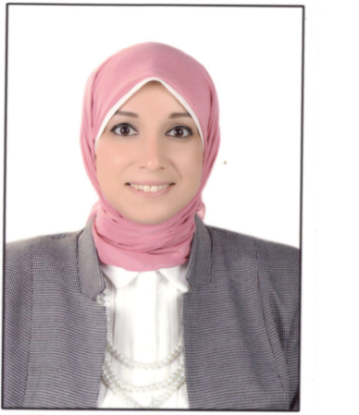

Name: Shereen Mohamed Mohamed Abd Elmonem.
Date of birth: 11-12-1986
Nationality : Egyptian
Marital status: Married
Mobile: 00201019213015
Address: Sidi-Beshr, Alexandria, Egypt
Email: Shereen_desoky@hotmail.com

Employment: Family medicine/General practitioner.

Education:

- Bachelor of Medicine and General surgery (M.B.B.Ch.) -Alexandria University- (2010).
- Master degree in Family Medicine -Alexandria University (Feb 2019).
- Toefel exam (successfully passed on Aug 2017).
- Have MOH –UAE evaluation letter and can join immediately.

Workshops:
- Workshop of Family Planning in Dar Ismaeel Hospital (Dec 2012).
- Workshop of Human Development -Alexandria University (Apr 2009).

Work Experiences:
- Family Medicine Specialist at Borg El Arab Family Health Center in Alexandria, Egypt (From Feb 2019 till now).
- Family Medicine Resident at Borg El Arab Family Health Center (5/2013-2/2019).
- General Practitioner at Borg El Arab Family Health Center (5/2012-5/2013).
- House Officer in Alexandria University Hospitals from (3/2011-2/2012).
- School Doctor at Pioneers International Schools (From Oct 2017 till now).

Conferences attended:
- 27 th Annual Scientific Congress in Medical Research (Alexandria 2006).

Computer Skills:
- Windows systems.
- Microsoft Office Word.
- Microsoft Office Power point.
- Internet.

Language skills:
- Arabic: mother tongue.
- English: very good.
Soft skills:
- Communication skills and effective listening.
- Independent & Team work.
- Problem solving.
- Able to adapt to varying workloads & task requirements.
- Presentable.

