# SHERLY SAJI

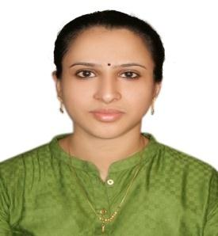**Mobile: 055-5079765,056-8027812**

**Email : sherlysaji84@gmail.com**

## CAREER SUMMARY:

I am having a medical back ground (paramedical nursing graduate) with 11 plus years of experience in handling Medical claims including medical billing, approvals, and submissions in UAE. Well acquainted with ICD 10 and CPT coding guidelines.

## Educational Qualification:

**Paramedical nursing (2 YEAR COURSE)**

**CPC Certification-Al Taluk Medical Coding -Deira Dubai**

## PROFESSIONAL EXPERIENCE:

**PRIOR APPROVAL OFFICER & CLAIMS SUBMISSION OFFICER: Arab Doctors Specialist Center since October 2018 till Now**

* Responsible for medical billing, prior approvals and submission
* E-Claim Submission using Mediware
* Reviewing claims prior to submission
* Taking Prior approval via different insurance portals and following up for the same.
* Handling insurance eligibility verification of patient through online portals

**Medical Insurance Coordinator: Mampilly Medical Center**

(**Jan 2007 -Aug 2018**)

* Trained insurance company's policies & procedures clarification to front desk staff

Nurses and doctors.

* Coordinated with Insurance Company for all insurance related matters.
* Taken prior approvals through telephonic and online approvals through portals of different insurance companies
* Reviewed and Submitted E-Claims through DHA portal.
* Handle efficiently Medical and insurance billing with collection of copayments/ coinsurance.
* Well versed with the Knowledge of insurance card screening, validity, coverage, network, copayments.

**I hereby declare that the information provided by me in my resume is true to the best of my knowledge and belief.**

**Place : Sharjah**

**Date : Sherly saji**